Channel Reallocation for Reducing Power Consumption in Femtocell Mobile Networks

Xuan-Bac Nguyen¹, Nam-Hoang Nguyen¹, Takahiko Saba²
¹ University of Engineering and Technology, Vietnam National University, Hanoi
² Chiba Institute of Technology
Email: ngxbac.dt@gmail.com, hoangnn@vnu.edu.vn, saba@cs.it-chiba.ac.jp

Abstract – Future mobile networks are known to deploy a two-tier architecture of macrocell – femtocell [1]. In the two-tier architecture, femtocell downlink channels can cause strong co-channel interference to downlink transmission of macrocell users (MUs) which use the same frequency. The co-channel downlink interference to the MU might cause the MU’s QoS degradation. To maintain the QoS of the MU’s connection, the serving macro base station (MBS) has to increase the transmission power of the macrocell downlink. The power increment will also cause more co-channel interference to other MUs of the neighbor MBSs thus results in increasing downlink transmission power of the macrocell subsystem. In this paper, we analyze the co-channel downlink interference and then propose downlink channel reallocation schemes, denoted as MBS-sensing and CFAP-sensing schemes, in order to reduce the power consumption of the macrocell subsystem. Simulation results prove that using channel reallocation schemes provide much better downlink power consumption efficiency than the case when the channel reallocation is not deployed. In general, the CFAP-sensing scheme has better performance than the MBS-sensing scheme. However, when femtocells have long coverage radius, the MBS-sensing scheme is the better solution because it is less complex and has similar performance.
Keywords – Femtocell, Channel Reallocation, Power Consumption, Co-channel Interference Management

I. Introduction
Next generation wireless communications technologies are expected to provide high data transmission rate and excellent service quality to mobile subscribers. It leads to an unpredicted growth of the number of mobile users in the future [2]. Therefore, efficient power consumption in mobile networks is becoming a challenging and difficult issue. Cognitive radio and femtocell are considered as the key technologies which are expecting to build cognitive cellular-femtocell mobile networks for the future mobile communications [3, 4, 5]. In cognitive cellular-femtocell networks, when a MU moves from outdoor to indoor environment, its signal strength received from the serving MBS is decreased resulting in the degradation of its QoS. To guarantee MU’s QoS, the covering MBS has to increase its downlink transmission power. This might lead to the disconnection of the MU if the transmission power reaches the power limitation. Increasing downlink transmission power of a MU’s connection will increase the co-channel interference to other MUs and femtocell users (FUs) who are using the same downlink channel. This leads to the demand of re-allocating a new downlink channel for the MU in order to guarantee its QoS requirements, reduce the co-channel interference and the system power consumption.
In this paper, our aims are to propose a new and low load method for downlink power transmission control for reducing the energy consumption. We will first present and analyze a downlink transmission model of cognitive cellular-femtocell networks which are used as a general two-tier network model of future mobile networks. Then, we formulate the problem of downlink power consumption which shows the necessity of downlink power management when a MU moves from a macrocell zone to a femtocell zone. We then propose and analyze performance of two channel reallocation schemes which one is designed based on the information measured at cognitive femtocell access points (denote as CFAP-sensing scheme), and another uses interference information measured at macrocell base stations (denote as MBS-sensing scheme). These schemes reallocate new channels to mobile MUs when the MU’s downlink transmission power exceeds the maximum power defined by the system design and configuration. New reallocated channels are expected to consume lower downlink transmission power, reduce the co-channel interference to other users and reduce the power consumption of cellular-femtocell networks. We will then investigate and compare the power consumption efficiency when these two schemes are deployed with the situation when the systems do not deploy a channel reallocation procedure in order to prove the benefits of channel reallocation schemes.
The paper is organized as follow: the system model and related works are presented in the next section. The problem formulation is described in section III following by the description of two channel reallocation schemes. Performance comparison is presented and discussed in section IV. Finally, conclusion remarks are given in the last section.

II. System model and related works
The generic system model of femtocell mobile networks used in our research is shown in Fig. 1. Assumed MBSs and CFAPs use the same downlink frequency spectrum in which MBSs belong to the primary system. CFAPs are indoor access points which are provided by network operators and form a secondary system. Femtocell Gateways (FGs) connected with CFAPs via the Internet exchange control message and interference information with Mobile RAN Management System (MRMS) via the core network of the cellular domain. The interaction between these control entities is for supporting mobility management and radio resource management by exchanging important information such as the channel usage condition of MBSs or CFAPs. Regarding to QoS provisioning in mobile communications, in order to provide user’s QoS, the signal quality of mobile users must have a certain SINR level [6]. The SINR level of an application type (voice, video, and data) is considered as the physical layer QoS (denoted as QoS).

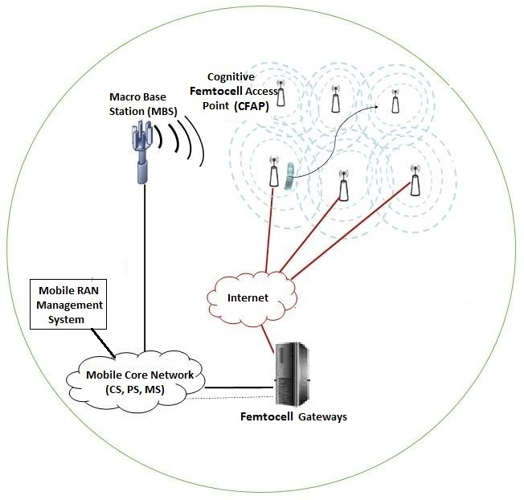
Figure 1. System model
In the two-tier architecture, interference management becomes an important issue. A good interference management mechanism will result in efficient power consumption. The definition of “green communication” and the importance of reducing the power consumption of cellular networks were discussed in [6]. The authors in [7] proposed an interference-mitigation optimization algorithm based on chemical-reaction theory to optimize the energy efficiency of the two-tier network system considering fixed users and QoS constraints. In [8], the authors proposed a complex self-organization strategy for resource allocation which uses cognitive radio and QoS constraint to avoid the co-tiered interference. In [9], the authors proposed a complex Stackelberg equilibrium solution to solve the power consumption efficiency problem in cognitive cellular femtocell networks. The authors in [10] proposed a joint power control and resource allocation using Hungarian algorithm for femtocells networks in order to achieve near optimal performance. These interference mitigation and resource optimization methods did not deal with the dynamic changes of network traffic when the user’s connections arrive and leave the network dynamically. These proposed methods also have high computation complexity which is a drawback when the number of macro base stations and femtocells increases.

III. Channel reallocation

III.1. Problem analysis
Figure 2. Interference model
As illustrated in Fig.2, consider the network configuration where MBSs are equipped with directional antennas of 120 degree for each sector. In sector II, the CFAP3 has FU1 who is using downlink Channel-1. At this time, the MU3 using the same downlink Channel-1 moves from outdoor into this CFAP3’s coverage area. Due to the penetration loss and losses caused by the indoor environment, the signal strength of MU3 received from the serving MBS is significantly reduced. The co-channel interference from the CFAP3 to the MU3 will increase [11]. Consequently, the serving MBS needs to provide higher transmission power in order to maintain the connection quality of MU3. However, increasing of the transmission power of MU3 also increases co-channel interference to neighboring MBSs. Thus, the power consumption of the whole system will increase. We prove the problem by the below mathematical analysis.
Consider a MBS^{i} of a femtocell mobile network which has n MBSs. Assume that there is a MU who is using downlink channel C and moves into a CFAP’s coverage area (denote as dCFAP–destination CFAP). The dCFAP has a FU who is also using the downlink channel C. Assume that P^{i}_{MBS} and PL^{i}_{M} are the downlink transmission power and path loss between the serving MBS^{i} and the MU, respectively. P_{dCFAP} is the downlink transmission power of the dCFAP. PL_{F} is the path loss between the dCFAP and the MU.
We assume that co-channel downlink interference at the MU is almost caused by downlink transmission of neighboring MBSs and the dCFAP. We eliminate their interference caused by other CFAPs under the assumption that their interference is much smaller than the interference caused by dCFAP.
When the MU is out of coverage of dCFAP (in outdoor environment), the total co-channel interference from neighboring MBSs and CFAPs measured at MU is:
(1)
Denote P_{R} is the downlink signal power that the MU received from the serving MBS^{i} :
(2)
Reminding that the Signal to Interference and Noise Ratio (SINR) of the MU must be higher than the predefined QoS requirement.
(3)
Equivalently:
(4)
(5)
The minimum required value of the downlink power P^{i}_{MBS} transmitted from MBS^{i} to the MU when it is out of dCFAP’s coverage area is:
(6)
Now, consider the situation when the MU moves into indoor environment (the coverage area of dCFAP). In this case, denoteand is the path loss from the serving MBS^{i} and a MBS^{j} to the MU, respectively. is the path loss from the dCFAP to the MU. We can formulate the calculation as:
and (7)
(8)
With w is the wall loss (dB). Similarly, the minimum required value of the downlink transmission power which the MBS i uses for the MU when the MU moves to indoor environment is:
(9)
Consequently, we get the approximated difference of the downlink allocated transmission power when the MU stays in the indoor and outdoor environment:
(10)
When the MU moves to indoor environment, the value of is high. In this case, the serving MBS^{i} needs to increase downlink transmission power of the mobile MU in order to maintain the QoS of the downlink channel when the mobile MU moves from outdoor to the dCFAP’s coverage area. This requires the demand of channel reallocation for the downlink transmission of the MU for achieving the efficient power consumption.

III.2. Channel reallocation schemes
In order to reduce downlink transmission power when the MU moves from a macrocell zone to a femtocell zone, two approaches can be exploited:
- Performing handover of the MU from its serving MBS to the destination CFAP: the MU will be served by the CFAP with very small downlink transmission power. However, this method is not suitable for mobile MUs who will probably reside in the CFAP a very short time because the coverage of CFAPs is small. Handover from MBSs to CFAPs also has problem of long delay which might cause QoS degradation of MUs.
- Downlink channel reallocation: the serving MBS will have to collect and monitor the interference of channels in the spectrum range and select a new channel for reallocation. Collecting and monitoring channel interference can be carried out by either only MBSs or by coordination of MBSs and CFAPs. We propose two downlink channel reallocation schemes which operate as following.
- MBS-sensing scheme for channel reallocation
In this downlink channel reallocation scheme, collecting and monitoring channel interference are performed by MBSs by using cognitive functions in terms of spectrum sensing and interference measurement. When a serving MBS detects that the SINR of a MU is decreasing while the downlink transmission power of the MU exceeds the maximum value, the serving MBS of the MU will attempt to select a new channel to reallocate to the MU by using following procedure:
- The serving MBS measures the interference level of all free channels of the serving MBS i.e. the channels which are not allocated to any other MUs in the serving MBS.
- The serving MBS selects a free channel which has the smallest interference level.
- CFAP-sensing scheme for channel reallocation
This scheme aims to exploit local interference information of the MU in order to have higher decision accuracy. CFAPs use spectrum sensing techniques to collect the information of interference level of channels in the spectrum range. A CFAP will send its interference record of the interference information to the femtocell gateways (FGs) which can be exchanged with the mobile RAN management system (MRMS).
When a serving MBS detects that the SINR of a MU is decreasing and its downlink transmission power exceeds the maximum value, the serving MBS will:
- Send a request to the MU to ask for performing a channel reallocation process. The MU has to send the ID of the CFAP from which the MU receives the strongest pilot signal. The serving MBS then requests the MRMS for the interference record of the CFAP.
- Select a new channel for the MU. The new channel must not be used by the serving MBS currently and has the smallest interference measured at the CFAP.

IV. Performance Comparison
In simulation scenarios listed in Table 1, a femtocell mobile network consists of nineteen MBSs which have the coverage radius of 500m and are located in the well-known two ring 19-cell model. Mobile users and CFAPs are uniformly distributed within a MBS’s coverage. A MU is severed by only one MBS at a given time. The location of a CFAP is fixed and its information (ID, location, etc.) is collected by the FG and MRMS when the CFAP is deployed. In simulation scenarios, the arrivals of MUs to a MBS and FUs to a CFAP follow the Poisson process with the predefined call arrival rate given in Table 1. Additionally, each MU and FU has a random call holding time based on the exponential distribution with the mean of 180 seconds. The total power consumption of the network is considered as the sum of the downlink transmission power of all MBSs and sampled every 5 seconds. We evaluate the power consumption efficiency by comparing the cumulative distribution function (CDF) of the total power consumption of the network when: 1) The network does not deploy the channel reallocation; 2) The channel reallocation is deployed by using the CFAP-sensing based scheme and the MBS-sensing based scheme. Path loss models and simulation parameters are described in Table 2 and Table 3, respectively [11, 12].
Table 1: Simulation scenarios
Configurations  Scenario | Number of CFAPs / MBS | Call arrival rate of MUs (calls / min) | Call arrival rate of FUs  (calls / min) | CFAP coverage radius (m)
Scenario 1 | 10 | 5 | 1 | 10
Scenario 2 | 15 | 5 | 1 | 10
Scenario 3 | 10 | 5 | 1 | 15
Table 2: ITU standardized path loss models
Parameters | Values
External wall loss | 20dB
Window loss | 5dB
Indoor to indoor path loss modeling | ITU P.1238
Indoor to outdoor path loss modeling | ITU P.1411 + wall/window loss
Outdoor to outdoor path loss model | Cost231 -Okumura-Hata for edge of macrocell  ITU P.1411 for near macrocell cases
Outdoor to indoor path loss model | Cost231-Okumura-Hata for edge of macrocell  ITU P.1411 for near macro cell cases  + wall/window loss
Frequency | 2GHz
Table 3: Simulation parameters
Parameters | Values
MU’s downlink SINR requirement | 5dB
FU’s downlink SINR requirement | 10dB
MBS’s transmission power range of a downlink connection | 1mW to 200mW
FAP’s transmission power of each downlink connection | 1mW to 20mW
Indoor to indoor lognormal shadowing standard deviation | 4dB
Indoor to outdoor lognormal shadowing standard deviation | 12dB
Outdoor to outdoor lognormal shadowing standard deviation | 8dB
Outdoor to indoor lognormal shadowing standard deviation | 10dB

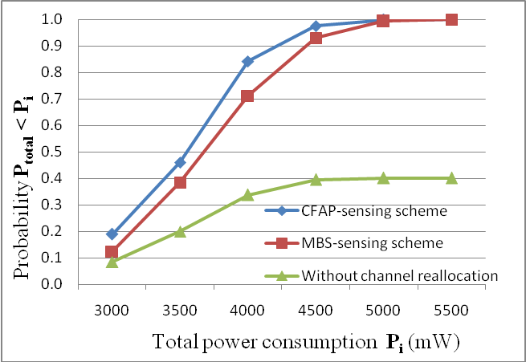
Figure 3. CDF of Total Power Consumption in Scenario 1

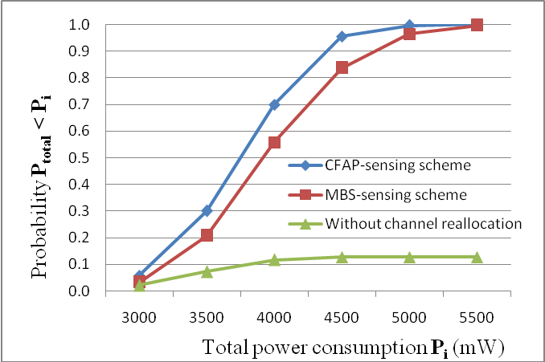
Figure 4. CDF of Total Power Consumption in Scenario 2
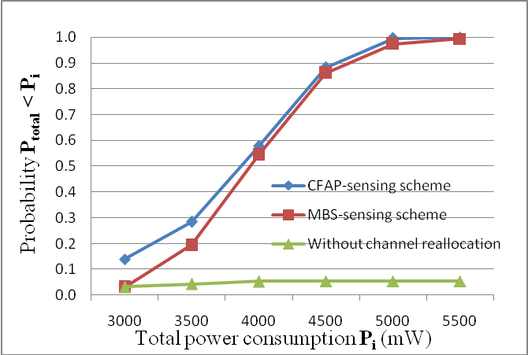
Figure 5: CDF of Total Power Consumption in Scenario 3
Figure 3 shows the CDF of the system power consumption of the first simulation scenario. For example, at the value P_{i} of 4500mW, if the system does not apply channel reallocation, there are only 40% samples of the total power consumption less than 4500mW. It proves that if the channel reallocation is not applied, MBSs have to increase the downlink transmission power of MUs when they move to indoor environment. The total system power consumption is reduced when implementing the channel reallocation schemes. In this case, the proposed CFAP-sensing and MBS-sensing schemes can provide more than 90% samples less than 4500 mW. The CFAP-sensing scheme can provide the lowest system power consumption because the CFAP-sensing scheme using the interference information measured at CFAP’s location, which is near the MU’s location. Therefore, this scheme can make more accurate channel reallocation decision.
Figure 4 describes the CDF of the total power consumption in the second simulation scenario. Different with the first scenario, in the second scenario, the number of CFAPs of a MBS is increased from 10 CFAPs to 15 CFAPs. When the number of CFAPs increases, the co-channel interference caused by CFAPs increases leading to the increase of the total system power consumption especially when the channel reallocation schemes are not implemented. The CFAP-sensing scheme still provides the lowest power consumption because the interference information collected at the CFAPs is more accurate than the information collected at the MBS.
Figure 5 illustrates the performance results of channel reallocation schemes when the radius of CFAP increases from 10 meters to 15 meters. It is shown that when the radius of CFAP increases, the performance of the MBS-sensing scheme now is getting better. It makes sense since the longer coverage radius of CFAPs directly affects the accuracy of the interference information measured at CFAP and thus decreasing the performance of the CFAP-sensing scheme.

V. Conclusion
In this paper, we have analyzed the co-channel interference of and the necessity of the downlink channel reallocation of two-tier femtocell mobile networks. We proposed and analyzed the power consumption efficiency of two channel reallocations schemes. Performance results obtained by computer simulation proves that using channel reallocation can achieve much better power consumption efficiency than not using channel reallocation. The CFAP-sensing scheme can provide the best performance but it requires more complex operation. The MBS-sensing scheme is able to provide better performance in the case of long coverage radius of CFAPs. Therefore, performing channel reallocation based on the interference monitoring at MBSs can be the less complex solution when the system deploys larger femtocells.
Acknowledgment
This work is supported by VNU-University of Engineering and Technology and Chiba Institute of Technology.
The authors are very grateful to Mr. Nhu-Dong Hoang, Viettel R&D Institute, for his valuable discussions and comments on the paper.

References
- Nguyen-Son Vo, Trung Q. Duong, Mohsen Guizani, "QoE-Oriented resource efficiency for 5G two-tier cellular networks: A femtocaching framework", in the Proc. Of the IEEE Global Communications Conference 2016, 5-8 Dec. 2016, pp: 1-6.
- Nokia Siemens Networks, White Paper 2020: Beyond 4G Radio Evolution for the Gigabit Experience.
- S. Al-Rubaye, A. Al-Dulaimi and J. Cosmas, “Cognitive femtocell: Future wireless network for indoor application”. IEEE Vehicular Technology Magazine, March . 03, 2011, pp 44-51.
- Gavin Horn, “3GPP Femtocells: Architechture and Protocols”, QUALCOMM Incorporated, Sep. 2010.
- Qualcomm’s presentation, “Femtocell”, http://www.qualcomm.com/media/documents/files/femtocells-the-next-performance-leap.pdf
- F.R. Yu, X. Zhang, and V.C.M. Leung, “Green Communications and Networking”, CRC Press 2012
- Lei Chen, Xi Li, Hong Ji, "Interference mitigation channel allocation algorithm for energy-efficient femtocell networks", in the Proc. Of Wireless Communications and Networking Conference 2014, 6-9 April 2014, pp: 2318-2323.
- Y.S. Liang, W.H. Chung, G.K. Ni, I.Y.Chen, H.K. Zhang, and S.Y. Kuo, “Resource allocation with interference avoidance in OFDMA femtocell network”, IEEE Trans on Vehicular Technology, Vol.61, No.5, June 2012, pp: 2243 - 2255.
- R.C.Xie, F.R.Yu and H.Ji,“Energy-efficient spectrum sharing and power allocation in cognitive radio femtocell network”, in the Proc. of the IEEE INFOCOM 2012, 25-30 Mar. 2012, pp: 1665 - 1673.
- Gen Cao, Dacheng Yang, Xuan Ye, Xin Zhang, “A downlink joint power control and resource allocation scheme for co-channel macrocell-femtocell networks”, in the Proc. of the IEEE WCNC 2011, 28-31 Mar. 2011, pp: 281 – 286.
- Intermational Telecommunication Union, “ITU-R Recommendations P.1238: Propagation data and prediction models for the planning of indoor radio communications systems and radio local area networks in the frequency range 900MHz to 100GHz”, Geneva, 2012.
- The femto forum, White Paper “Interference Management in UMTS Femtocells”, December 2010.

