Investigate magnetic field of dual Halbach array in linear generator using for wave energy conversion
Do Huy Diep, Dang The Ba* and Nguyen Van Duc
Faculty of Mechanics Engineering and Automation,
University of Engineering and Technology,VNU.

Abstract: Linear permanent magnet machines have wide applications in various areas. In the wave energy conversion, the use of linear generator has earlier been regarded as difficult and uneconomical. Many attempts have been spent to overcome difficulties [15-17] however, for real field application, there are still many problems. In this study, an attempt to improve the magnetic flux density in linear generator has been investigated. A dual Halbach array structure is investigated on parameters of line generator in wave energy converter to enhance flux density in air gap, thus to improve output performance of linear machine. Numerical result from finite element method is employed to simulate and observe the flux distribution in the machine. The result also shows that the double Halbach array has increased magnetic flux density compared to the schema used in linear generator of Direct driven wave energy conversion.
Keyword: Dual-buoy converter, coreless linear generator, magnetic flux field, Halbach array.

1. Introduction
The topic of renewable energy is an evergreen subject, especially, in a world dominated by fossil fuels. Renewable energy is widely talked about in the contemporary world because it is unlimited, which means it’s sustainable and does not emit greenhouse gasses that are detrimental to the environment and human health. A classic example of renewable energy is wave energy.
Wave energy, also known as ocean energy or sea wave energy, is energy harnessed from ocean or sea waves. The rigorous vertical motion of surface ocean waves contains a lot of kinetic (motion) energy that is captured by wave energy technologies to do useful tasks, for example, generation of electricity, desalinization of water and pumping of water into reservoirs.
Wave energy or wave power is essentially power drawn from waves. When wind blows across the sea surface, it transfers the energy to the waves. They are powerful source of energy. The energy output is measured by wave speed, wave height, and wavelength and water density. The more strong the waves, the more capable it is to produce power. The captured energy can then be used for electricity generation, powering plants or pumping of water. It is not easy to harness power from wave generator plants (through wave energy converter (WEC)) and this is the reason that they are very few wave generator plants around the world. [1]
WECs convert the mechanical energy of waves into electrical energy. WECs traditionally use a system which converts the slow linear motion of the wave energy absorber to a high speed rotating motion of generators which require complex mechanical interfaces. Alternatively, in many applications it can be use low speed generators or linear generators. The idea with direct drive linear generators is to reduce the complexity of the mechanical interfaces and thereby reduce the number of movable parts and to minimize the mechanical losses. The mechanical interface is in this way replaced with an electrical interface which can be expected to have a longer life time and less maintenance [2].
A linear trigonal double-face permanent magnet generator has been developed in VNU project – QG.14.01. The advantage of this model is the absence of steel core in coils that means no cogging force is induce. The limit of this model is weak output power due to the limited magnetic field inside the stator of generator. This research aims to increasing magnetic flux density and the output of linear generator by using dual Halbach arrays permanent magnets. So on, we investigate the magnetic field with various sizes of permanent magnets. The rest of paper is organized as follows: section 2 presents the comparison magnetic field strength between old model and new one. Section 3 introduces relation between magnet sizes and flux magnetic strength. Last section summarizes important findings in this study.

2. Linear Generator Using for Wave Energy Conversion
A schematic of a dual-buoy wave energy converter can be outlined as follows (Fig. 1) [2,3]. It consists of two-buoy point absorber. One is a big floating buoy, which connects to a tube. The other is a semi-submerged buoy which can free translate inside the tube. A linear permanent magnet generator that is a direct-driven conversion mechanism connects two buoys. The generator has a translator with coils in the form of a piston and a stator with permanent magnets of alternating polarity. The translator connects with the first buoy and the stator is rigid connected with the second buoy. The relative moving between two buoys make relatively translation between stator and translator. The current in the coils affects the translator with a electromagnetic force that will damp the translator motion. Controlling the power output from the generator makes it possible to affect the dynamic of the whole system.
The parameters that are connected to the ability to absorb energy are excitation force, radiation impedance and damping force. The first two parameters are dependent on the wave characteristics, buoy and translator geometry. By tuning the natural frequency of the mechanical system to coincide with the wave frequency, the translator oscillation will be resonance. This is called phase control. The last parameter, the damping force is related to the generator characteristics and how energy is extracted from generator, i.e. it depends on the electric load. A larger damping force will decrease the amplitude and the velocity of the mechanical oscillation. By changing load and in turn the power outtake it will be possible to control the absorption.
The use of linear generator has earlier been regarded as difficult and uneconomical. First, a linear generator has a varying speed and cannot be connected directly to the grid. Second, a linear generator has open magnetic circuits at cogging force. The cogging force cause oscillatory output, which shortens lifetime and increase the maintenance cost of the generators both ends of the generator which influence the magnetic flux in the generator. Third, a linear suffers from large. Although, to overcome difficulties many attempts have been spent but for real field application there are many problems.
A linear trigonal double-face permanent magnet generator has been developed for a double-buoy wave energy converter in VNU project – QG.14.01. This generator is suitable for using in slack-moored direct driven wave energy conversion. Based on the principle, a schema of generator and the connecting from generator to buoy is shown in Fig. (1) and (2). The advantage of this linear generator model is the absence of steel core in coils that means no cogging force is induced. In general, the generator has been designed in the form of tubular with N magnetic slots [11]. For more easy demonstrate here we use the form of three magnetic slots Fig. (2).
The most important parameter in a generator is magnetic flux field across to movement plane of the conductor in the coil. The self-inductance electromotive force is depends on turns of coils, magnetic flux density in generator. With the fix volume in generator, double Halbach arrays structure is applied to increase output magnitude. The schema of generator is shown in Fig. (3).
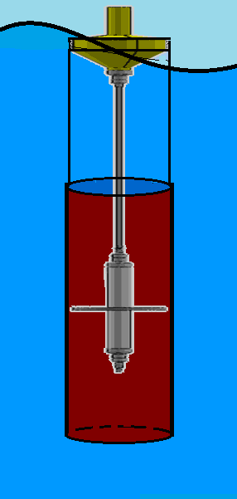
Fig. 1. Generator connect with buoy
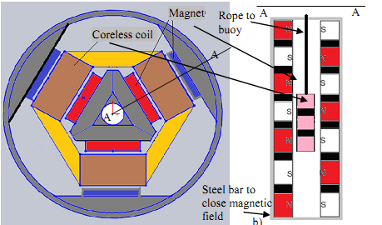Fig. 2. Schema of generator (a) cross section and (b) coils and magnets in the section A-A

3. Governing Equations
Due to the axial symmetry, we will investigate the 2D magnetic field in the plan along generator and across to center of a magnetic slot. For analysis magnetic flux field in generator with the arranging of magnet array, two case studies are simulated. In the first case, permanent magnets with size of length 25mm and width 10mm are arranged regularly with space 7mm as the following in Fig.2b. In the second uses double Halbach arrays magnets as shown in Fig. (3)
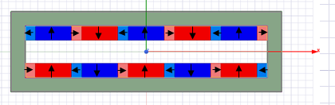
Fig. 3. The schema of magnets using double Halbach array structure.
Based on PM arrangement, magnetic field distribution in the generator is formulated with Laplace’s and Poisson’s equations. Numerical computation from finite element method is utilized to analyze and observe flux variation in air gap of generator.
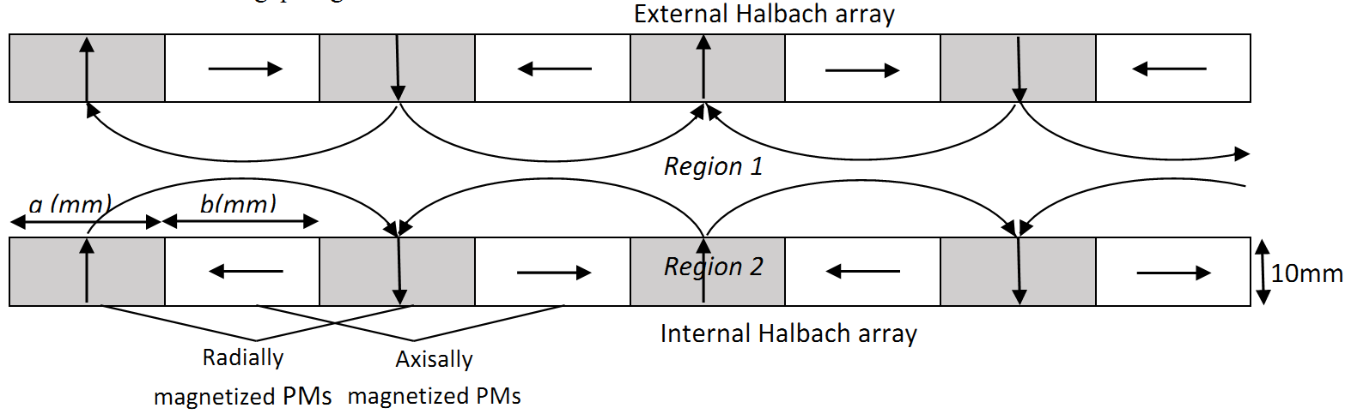
Fig. 4. Polarization pattern and geometry of dual Halbach array
In formulation of the magnetic field, the generator space under study is divided into two regions bases on magnetic characteristics. The air gap or coil space that has permeability of 1.0 is denoted as Region 1. The permanent magnet volume filled with rare-earth magnetic material is denoted as Region 2. The magnetic field property of Region 1 and 2 is characterized by the relationship between magnetic field intensity, H (in A/m) and flux density, B (in Tesla) as:
(3.1)
(3.2)
Where μ₀ is the permeability of free space with a value of 4π x 10⁻⁷ H/m, μ_{r} is the relative permeability of permanent magnets, M = B_{rem}/μ₀ is the residual magnetization vector in A/m, and B_{rem} is the remanence.
The governing equations of magnetic field, i.e. Laplace’s and Poisson’s equations, are significant for the solution of magnetic field. The Gauss’s law for magnetisms is state that
where i = 1,2.
Thus, we can have a magnetic vector potential, A_{i}, so that
(3.3)
Therefore the equation can be written as
(3.4)
In region 1, the combination of Maxwell’s equation and Eq. (3.1) gives
(3.5)
Substituting Eq 3.4 into 3.5 yields
where J(A/m²) is current density in the field. In permanent magnet J=0, therefore the Laplace’s equation for Region 1 is obtained as
(3.6)
For Region 2, the combination of Maxwell’s equation and Eq. 3.2 gives
(3.7)
Similarly, Eq. 3.4 and Eq. 3.7 yield the Poisson equation for Region 2
(3.8)
In next part, computational simulations will be conducted in accordance to FEM method and Ansys Maxwell tool to solve Maxwell equations to draw conclusion about magnetic field as well as magnetic flux density.

4. Finite Element Analysis and Results
The computational simulations can be categorized into 3 parts following the finite element method (FEM) using Ansys Maxwell tool to assist calculation. Material creating magnetic field in the simulation is NdFe35 with the following features.
Relative permeability | 1.0997785406
Bagnetic coercivity | -890000 (A/m²)
Bulk conductivity | 625000 (Siemens/m)
remanenceBr | 1.23 (Tesla)

Part I: Simulated calculation for 2 configurations of magnets in the generator. Configuration 1 is arranged as in Figure 2b, configuration 2 is arranged as in Figure 3, Figure 4. In configuration 1, there is only a polarized array of magnets along the y direction spaced 7mm apart, and the magnets dimensions are: 25mm long, 10mm wide. The magnet arranged in configuration 2 has the polarizations of Figure 4, in which the magnets along the y direction have the same size as configuration 1. The magnet configuration 2 differs from the magnets 1 by the presence of magnets polarizing along the X direction that fill the gap between the linearly polarized magnets. The magnets are 7mm long, 10mm wide. The distance between the two magnets is 16mm.
The figure shows that the magnetic flux density is increase when Halbach arrays structure is used. The blue-dot line shows the magnetic flux density at the center line of generator which is introduced in VNU project-QG.14.01, and red line shows the magnetic flux density of generator when double Halbach arrays structure is used. The maximum value of magnetic flux density at center can improved around 10.8% therefore the output performance can be significantly increase.
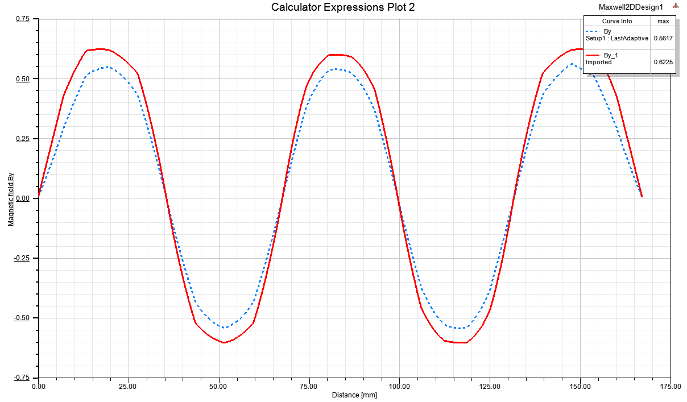
Fig. 5. Magnetic flux density at center of generator in two types.
Compared with the older configuration, the generator using the dual Halbacharray structure clearly demonstrates the superiority of generating a flux density from B with a greater maximum value than before. Therefore, the surveys of the flux density from the field B in the generator as well as the change of the flux density from B to the different sizes of the magnets are necessary to find the characteristics and optimum for the generator.
Part 2 of the computational simulations to understand the distribution of magnetic flux density in the generator cross sectional area according to configuration 2 above.
Figure 6 describes overall magnetic field distribution of a tubular linear generator with dual Halbach array. The structure parameters of Halbach array in the numerical computations: Y-axially polarization magnets size of 25mm length and 10mm width, X-axially polarization magnets size of 7mm length and 10mm width. In this simulation, magnets (material NdFe35) with Br=1.23
Fig. 6. Y axis magnetic field density (By) contribution of the generator
Fig. 7. X axis magnetic field density (Bx) ontribution f the generator
In generator, moving coils move along X axis, therefore only By component of the magnetic field across the coil to generate electromagnetic force. In generator, By component magnetic field could be presented as figure
Fig. 8. Magnetic Flux Density along Y axis from center to the outside of the generator
In Fig. 8 each line represents Y-axis magnetic field along with distance along X-axis. The distribution of magnetic flux field is harmonically functioning with period of PMs size. The amplitude at center line is minimum and amplitude of others line increase when it nears magnets. According to this characteristic, we can take average of magnetic flux density, thus magnetic flux density in the air gap can be written as
(4.1)
Where B_{(a,b)} is the value of maximum magnetic flux density that varies with the dimensions of Halbach PMs.
According to the Faraday law, the induced electromagnetic force depends on the magnetic flux variation in a unit of time.
For the purpose of increasing magnetic flux field, magnetic flux field is investigated with various length of Y-axis polarization and X-axis polarization PMs when the width is set at 10mm. In the next part, we investigate the maximum value of magnetic flux density by changing the length of Y axis polarization magnets a (mm) from 10mm to 40mm, and its dependence on the length of X axis polarization magnets b (mm), Fig. (9). (Describe in Fig. (4))
Fig. 9. Magnetic Flux density vs. length a of Y axis polarization
The value of magnetic flux density increases as the magnitude of the magnets increases, and asymptotically approaches a value that cannot be increased. Using this table, we can optimize the magnitude of the polarization length along the Y direction. Next, with the magnitude of the magnets with the longitudinal polarization determined a = 32mm, we continue to investigate the change of B max with the size change of the horizontal polarization magnet, Fig. (10).
Fig. 10. Magnetic flux density vs. length b of X axis polarization
Looking at the graph, we choose the optimal value of the horizontal polarization magnitude b = 25mm. From this we can choose value pairs based in length of magnet polarized vertically and horizontally so that the maximum magnetic flux value is obtained when the magnitude of the magnet along the Y axis is 32mm and the magnitude of the magnets along the X axis is 25 mm.
For the geometry’s parameters above, the Halbach array help to increase the output power of generator about 15%.

5. Conclusions
For overcome the disadvantages of using PM linear generator in wave energy converter, we have apply double Hallback array for a double face air core linear generator.
Ansys Maxell soft ware has been used to simulation magnetic flux field in generator. The result shows that the magnitude of flux magnetic field with double Halback array is greater about 10.8% in compaire with that normal double face array.
For improve more effect of double Halback array, the analysis of flux field on the dimensions of magnetic bars have been investigated, the results shown a “optimate” configuration for this study.
The results of this study will be applied for develope the double-buoy direct driven wave converter in UET-VNU.

Acknowlegement
This work has been supported/partly supported by VNU University of Engineering and Technology under project number CN17.07.

References
[1] J.M. Leishman and G. Scobie. The development of wave power, a techno-economical study. Dept. of Industry, NEL Report, EAU M25, 1976.
[2] N.J. Baker. Linear Generators for Direct Drive Marine Renewable Energy Converters. Doctoral thesis, School of Engineering, University of Durham, 2003.
[3] N.J. Baker and M. A. Mueller. Direct drive wave energy converters. Rev. Energ. Ren. :Power engineering, pages 1–7, 2001.
[4] Johannes Falnes. Ocean waves and oscillating systems. Cambridge. ISBN 0 521 78211 2, 2002.
[5] Dang The Ba, Numerical simulation of a wave energy converter using linear generator. Vietnam J. of Mechanics, Vol 35, No. 2, 2013.
[6] Dang The Ba, Doan Van Tien and Nguyen Hoang Quan, Designing and Analyzing of a Dual-Buoy 5kW Wave Energy Converter. Proceeding of The 8th Asia-Pacific Workshop on MarineHydrodynamics – APHydro 2016, September 20-23, Hanoi, Vietnam.
[7] K. Budal and J. Falnes. A resonant point absorber of ocean-wave power. Nature, 256:478–479, 1975.
[8] Jawad Faiz, Mahdi Ebrahimi-Salari, and Gh.Shahgholian, Rael Schmulian. Reduction of Cogging Force in Linear Permanent-Magnet Generators. IEEE Transactions on magnetics, Vol. 46, No. 1, pp 135-140, January 2010.
[9]. Boström , C., Electrical Systems for Wave Energy Conversion, Uppsala Dissertation. ISSN 1651-6714; ISBN 978-91-554-7982-4, 2011.
[10] O. Danielsson and M. Leijon. Flux distribution in linear permanent-magnet synchronous machines including longitudinal end effects. IEEE Transaction on Magnetics, 43(7):3197–3201, 2007.

[11] Dang The Ba, Nguyen Dong Anh, Phung Van Ngoc (2014), Numerical Simulation and Experimental Analysis for a Linear Trigonal Double-Face Permanent Magnet Generator Used in Direct Driven Wave Energy Conversion. ISSN: 1876 – 6169 Procedia Chemistry Volume 14, 2015, paper 130-137. Published by Elvesier.

