The 9th International Workshop on
ADVANCED MATERIALS SCIENCE AND NANOTECHNOLOGY
Ninh Binh City, Vietnam, 7-11 November 2018
Contact Address: IWAMSN 2018 Workshop Secretariat and Administration Staff
Institute of Materials Science, Vietnam Academy of Science and Technology,
18 Hoang Quoc Viet Road, Cau Giay District, Hanoi, Vietnam.
- Phone: (84-4) 3.7568870 - Fax: (84-4) 3.8360705
- Email: iwamsn2018@ims.vast.ac.vn - Website: http://www.iwamsn.ac.vn

ABSTRACT FORM
(Submission Deadline: 15 August 2018)

Title: High sensitivity marine electronic compass equipment based on magnetoelectric effect of magnetostriction-piezoelectric composites
Category Oral presentation Poster presentation
x

Session: 6. Advanced Metals and Composites (code: AMC)
.
Author(s): P.A. Tuan, N.V. Tuan, N.B. Bien, N.H. Duc and D.T. Huong Giang
Institution: University of Engineering and Technology, Vietnam National University, Hanoi
Speaker: Phung Anh Tuan
E-mail: giangdth@vnu.edu.vn
Abstract: A novel marine electronic compass devices has been developed by integrating magnetoelectric geomagnetic sensors. The 1-D single sensors were fabricated using laminated composites of soft magnetic Ni-based Metglas ribbons and piezoelectric plate. The compass device consists of two 1-D single sensors in an orthogonal arrangement that permit to determine the angle respect to the magnetic North (Azimuth angle) by simultaneously measuring two components of geomagnetic field in horizontal plane. The investigations were performed by modelling and theory calculating for optimizing configuration, size and shape of single sensor element as well as optimizing noise floor in orthogonal assembly. With extremely high sensitivity (~ 1 V/Oe) and resolution magnetic field (~ nT) thanks to the enhancement of magnetic softness and uniaxial magnetic anisotropy, a highly sensitive angular sensor was successfully investigated and manufactured. Based on sensor working principles, an electronics circuit was developed, designed, assembled and packaged. The algorithms included auto-offset compensation, orthogonal error estimate, auto-calibration and Azimuth angle calculation were built that enables precisely measure angular position with a high sensitivity of 0.1 degree. This investigated high sensitivities but low-cost instrument are comparable with current commercial products.

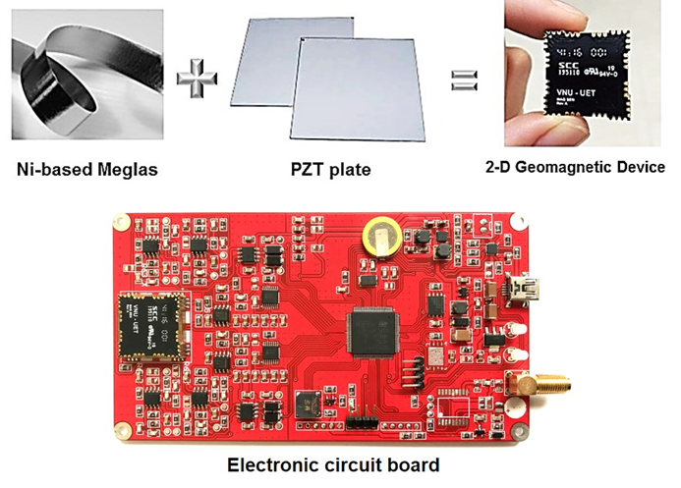
Fig. 1. Navigation electronic compass instrument based on magnetoelectric effect of magnetostriction/piezoelectric composites

