The 9th International Workshop on
ADVANCED MATERIALS SCIENCE AND NANOTECHNOLOGY
Ninh Binh City, Vietnam, 7-11 November 2018
Contact Address: IWAMSN 2018 Workshop Secretariat and Administration Staff
Institute of Materials Science, Vietnam Academy of Science and Technology,
18 Hoang Quoc Viet Road, Cau Giay District, Hanoi, Vietnam.
- Phone: (84-4) 3.7568870 - Fax: (84-4) 3.8360705
- Email: iwamsn2018@ims.vast.ac.vn - Website: http://www.iwamsn.ac.vn

ABSTRACT FORM
(Submission Deadline: 15 August 2018)

Title: Design, simulation and fabrication of a high sensitivity micro-magnetometer integrated with microfluidics system and flux concentrators for biomedical applications.
Category Oral presentation Poster presentation

Session: 3. Nanotechnology in Life Science and Environment Technology (code: NLE)
.
Author(s): H.A.Tam¹, N.V. Hung¹, D.T. Huong Giang¹, N.H. Duc¹, C.G. Kim^{1,2}
Institution: ¹VNU Key Laboratory for Micro-Nano Technology, University of Engineering and Technology, Vietnam National University, Hanoi
² Department of Emerging Materials Science, DGIST, Republic of Korea
Speaker: Ho Anh Tam
E-mail: hoanhtam@gmail.com, hoanhtam@vnu.edu.vn
.
Abstract: Biomagnetism is the phenomenon of magnetic fields emitted by living organisms including cells. Magnetic field strength produced by cells or even with cells marked by magnetism (called biomarkers) are generally very weak. For this reason, cells/biomarkers (bio-samples) detection usually were done by directly contacting the bio-samples with sensor surface that would cause to degradation of sensor performance after some measurements. To deal with such situation, using an annular-shaped flux concentrator made by a high magnetic permeability material to increase magnetic amplification in sensor’s surface is necessary. Beside, this solution also supports for the measurement without contact. In this paper, we describes the results in design, simulation and fabrication of a high sensitivity micro-magnetometer integrated with microfluidics system and flux concentrators for biomedical applications (Fig. 1a). From simulation toward experiment, the results showed that by using the optimal annular-shaped flux concentrator to focus flux lines on sensor’s surface, the sensor signals is more than ten times higher than in the case directly contact method (Fig. 1b). The system opens up the potential for widespread use in lab-on-a-chip for biomedical applications and commercialization.

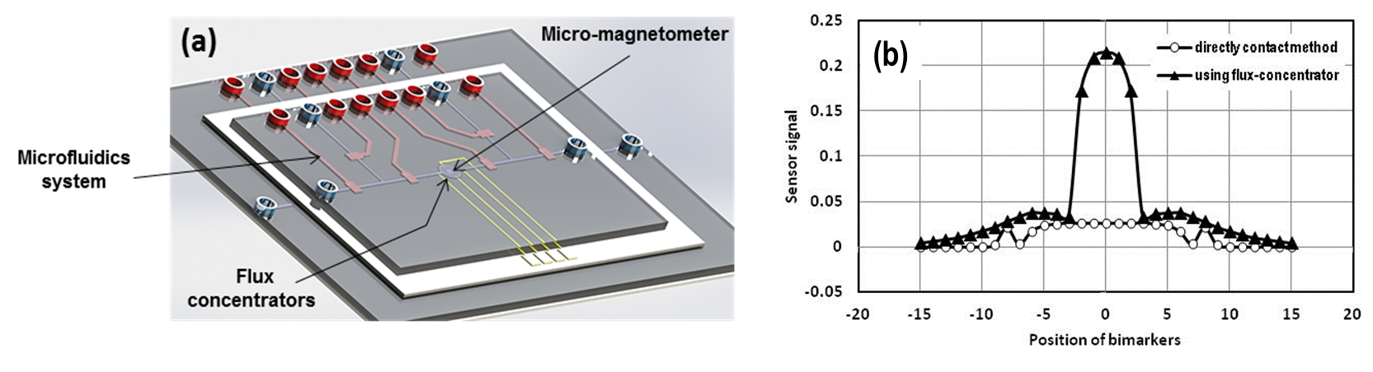
Fig. 1. Micro-magnetometer integrated with microfluidics system and flux concentrators: (a) 3D design and (b) sensor signal response with bio-marker

