Design and simulation of a DC stabilization system for solar energy system

Pham Thi Viet Huong1, Mac Khuong Duy2, Tran Anh Vu2, Dang Anh Viet1, Minh-Trien Pham1

*1University of Engineering and Technology, Vietnam National University, Hanoi, Vietnam*

*2Hanoi University of Science and Technology*

Abstract

During the last few years, the market for solar photovoltaic (PV) energy has grew remarkably since it provides electricity from an exhaustible and clean energy source. The generated power from the panels depends on environment conditions, which changes continuously. In order for the system operates at its most efficiency, it needs to work at its maximum power point (MPP). In this paper, Maximum Power Point Tracking (MPPT) algorithms are discussed and implemented. While the system works at its MPP, an adaptive load is utilized to obtain a steady and reliable desired output voltage. Previous literature has dealt with either investigating MPPT algorithms or tracking a steady output voltage from solar panels, not both. Our paper fulfilled that gap in literature. It is not only able to obtain a reliable steady DC output voltage but also keep the solar system work at its maximum efficiency. A Proteus simulation confirmed our theory and implementation.

*Keywords:* solar panels, MPPT, MPP, stability, DC-DC converter

1. **Introduction**

Renewable energy has been rapidly growing used to replace the conventional fossil fuel plants, which is a primary source of global warming and greenhouse gas emissions. Other than the problem of environmental issues, fossil fuels has been depleting due to unlimited exploitation of humans. Moreover, the rapid increase in the demand for electricity has led to a need for an alternative source of energy. Renewable energy such as solar energy, wind power, hydropower has been used increasingly due to its affordability, sustainability and environment friendliness [1]. The most challenging problems of renewable energy are based on its efficiency and manufacturing cost.

Among these sources, solar energy has been paid attention and offers promising results in providing clean energy. It is made of photovoltaic cells which convert solar irradiation to electricity. Solar energy has been more and more popular due to its advantages such as low maintenance cost, pollution and noise free [1]. [1]

However, the efficiency of the solar panel is low, only between 10% and 12% in converting sunlight to electricity [2] [3]. The efficiency of the solar panels depends on the amount of sunlight falling on the panels and the electrical characteristics of the load. As the amount of sunlight varies, the load characteristic that gives the highest power efficiency changes. The efficiency of the system is optimized when the load characteristic changes to keep the power transfer at highest efficiency. Moreover, each solar system has its own peak point of energy and normally, it may not need to operate at its maximum point. Hence, a constant effort of researchers have been made to utilize the sunlight energy to the most. That is why the concept of Maximum Power Point Tracking (MPPT) has been developed, to find the maximum point of the output power from the solar system and keep the load characteristic there.

In recent literature, there are two trends that researchers have been concentrated on. The first one is conducting algorithms to find the best maximum power point; the second is to mainly concern on the stability of the output voltage extracted from solar panel. As far as our understanding, there is no such research that has been able to extract a stable steady DC output voltage while keeping the solar panel operate at its maximum efficiency. Our paper can do both tasks at the same time. Our algorithm can be able to obtain any desired steady DC voltage. In our simulation, we set the output voltage as 12V and 24 V for example, as it is the standard DC power supply in the market.

Conventional MPPT techniques work by sensing the current and voltage from the solar panels while duty cycle signal from the MPPT operates on the maximum power point (MPP) as presented in Figure 1. In order to maximize the output power from solar system, it has to be operated at a unique point with specified load resistance. This requires a separate power converter for the MPPT. In our design, a boost DC-DC converter is used to match the load to the PV array to extract the maximum power. Regarding the algorithm for MPPT, there are three most common traditional techniques, which are Perturb and Observe (P&O) [4] [5] [6] [7], Incremental Conductance (INC) [5] [8] [9], and Hill Climbing (HC) [10] [11]. The details on each algorithm will be discussed later.

PV panel

DC-DC

Converter

Load

MPPT

Switching signal

Input voltage and current

Figure 1: MPPT system block diagram

In order to obtain a desired DC output voltage, in this research, we substitute a fixed load in Figure 1 by an adaptive load, which can output any desired voltage. In [12] [13] [14] [15], a control law based on systematic state-space approach to keep the output voltage stable, which can be applied to solar energy system. In this paper, a simpler feedback is designed to obtain the desired output voltage as shown in Figure 2.

PV Panel

DC-DC Converter

DC-DC Converter

Load

MPPT Control

Controller

Input voltage   
and current

Output voltage

PWM1

PWM2

Figure 2: Design of the whole system

In future research, the authors intend to implement the above mentioned methods for the same purpose. Results confirmed our theory and will be illustrated in later section.

The paper is organized as follow. Section 2 is the modelling and simulation of the PV panels. Section 3 is an overview on different traditional MPPT techniques. Section 4 presents the simulation’s setup and results. Section 5 concludes the work.

1. **2. Photovoltaic (PV) panels modelling and simulation**
   1. *Modelling of the photovoltaic system*

A practical model of a single solar cell can be modelled in Figure 3.



Iph

ID

Ish

I

Rs

+

D

Rsh

V

_

Figure 3: Modeling of the solar cell

The solar cells can be connected in series or parallel due to its application’s requirements. The interconnected solar cells are known as PV array. In this figure, $R_{s}$ represents series resistance of pn junction cell and $R_{sh}$ is the parallel resistance. $I_{D}$ and $I_{sh}$ are diode current and shunt leakage current, respectively. Applying the Kirchhoff’s Current Law (KCL) in the equivalent circuit of solar cell, we have the total output current can be calculated as:

$I=I_{ph}-(I_{D}+I_{sh})$ (1)

If we let $I_{o}=I_{D}+I_{sh}$, is the solar cell reversed saturation current, which is calculated in [16]

$I_{o}=I_{rs}{\left(\frac{T}{T_{ref}}\right)}^{3}exp⁡\left[\left(\frac{qE_{go}}{AK}\right)\left(\frac{∆T}{T_{ref}T}\right)\right]$ (2)

Where $I_{rs}$ is reserve saturation current of cell for the nominal temperature and irradiance values and $E_{go}$ is band gap energy of semiconductor material.

The photo current $I_{ph}$ is generated on absorption of solar radiation by solar cell, hence it is directly related to variation in solar irradiance and temperature [17]

$I_{ph}=(I_{scr}+k_{i}∆T)\frac{G}{G_{r}}$ (3)

Where in this equation, $I_{scr}$ is rated solar current at nominal weather conditions (temperature is at 25oC and solar irradiance is 1000W/m2), is the short circuit temperature coefficient. $G$ is solar irradiance in W/m2, and is nominal irradiance in normal weather conditions. $∆T$ equals to $T-T_{ref}$, the difference between operating and nominal temperature

The output current of the cell is given, according to [18]

$I=I_{ph}-I_{s}\left[\exp\left(\frac{q(V+IR_{S}}{kT_{c}A}\right)-1\right]-\frac{V+IR_{S}}{R_{sh}}$ (4)

Where $I$ and $V$ are the current and voltage of the photovoltaic panel, respectively

$I_{ph}=N_{p}I_{ph, cell}$ is the photo-generated current in the PV module consisting of $N_{p}$ cells connected in parallel, $I_{ph, cell}$ is the current generated of each cell.

$I_{s}=$ $N_{p}I_{s, cell}$ is the reverse saturation current of the PV module consisting of $N_{p}$ cells connected in parallel, $I_{s, cell}$ is the reverse saturation current of each cell.

$k$ is the Boltzmann’s constant, $k=1.38×{10}^{-23} J/K$

$q$ is the electronic charge, $q=1.602×{10}^{-19}C$

$T_{c}$ is the temperature of the array in Kelvin

$A$ is the ideality factor of the diode, $A=1.0\sim 1.5$

$R_{S}$ is the equivalent series resistance of the PV array

$R_{sh}$ is the equivalent parallel resistance of the PV array

* 1. *Simulation of the photovoltaic system*

*a. Dependence of the output power on environment temperature*

In this section, we will investigate how the output power from the photovoltaic array changes according to environment temperature. According the above equations, when temperature increases, the output current from the solar panel will increase, then the power increases. In our simulation, when the series resistance $R_{S}$ and the parallel resistance $R_{sh}$ are set to 0.38 $Ω$ and 153.56 $Ω$, respectively, the photo-generated current $I_{ph}$ is 3.81A.

The changes in the output power according to environment temperature are illustrated in Figure 4. When the temperature is set to 25 oC then the output power we obtained is approximately 60W. When the outside temperature increases to 50oC, other factors are kept constant, the output extracted from the solar panel increases up to 65W.

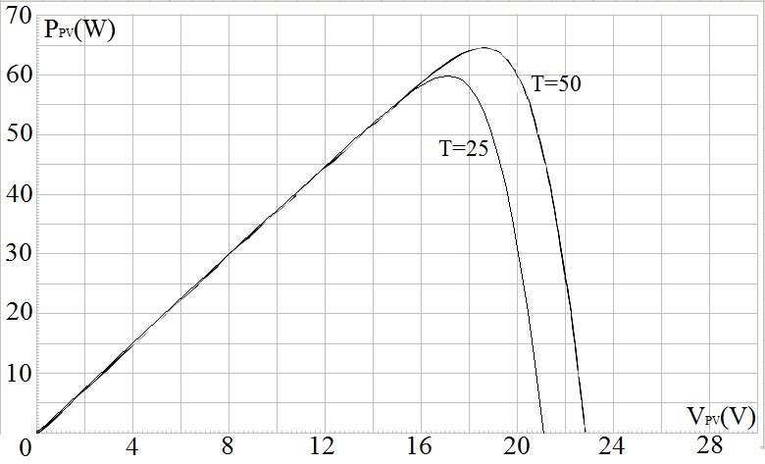

Figure 4: Output power changes according to environment temperatures

*b. Dependence of the output power on the photo-generated current*

The dependence of the power on the photo-generated current $I_{ph}$ is given in Figure 5. When the photo-generated current increases from 4.5A to 5A, the power increases from approximately 71W to 79W.

1. **Maximum Power Point Tracking algorithms**

The maximum power is generated by the solar module at a point of the I-V characteristic where

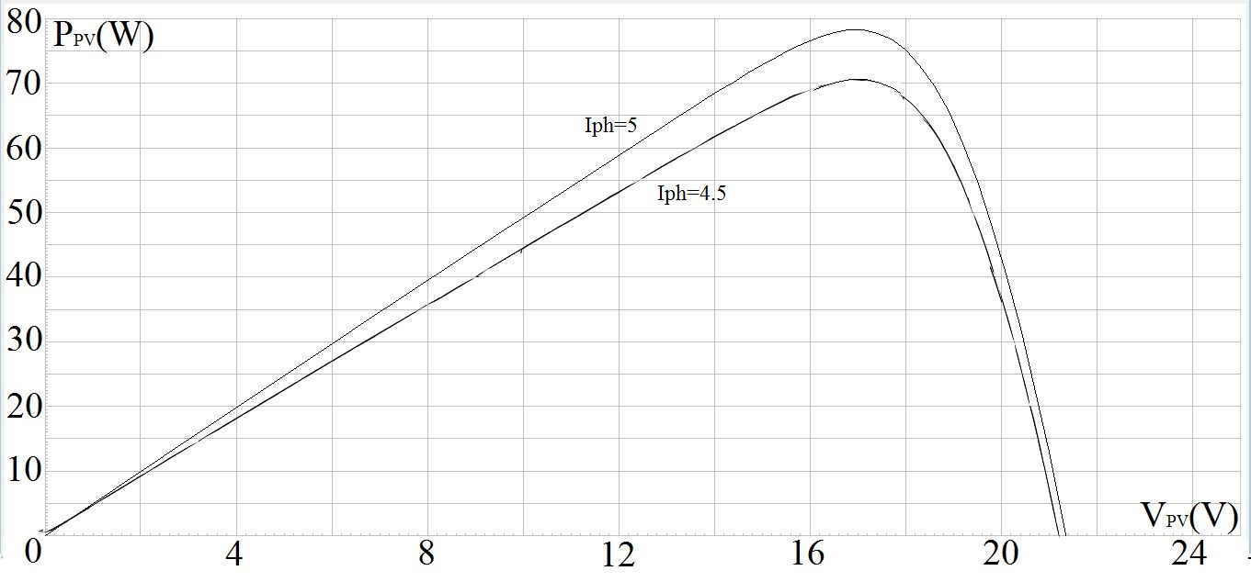

Figure 5: Output power changes according to Iph

the product of voltage and current is maximum. This point is called the Maximum Power Point (MPP). The role of the MPP is to ensure the operation of the PV module at its MPP, extracting the maximum available power. If there is a good irradiance condition, the photovoltaic system can generate maximum power efficiently while an effective MPPT algorithm is used with the system. In recent literature, there are three main traditional MPPT algorithms: Perturb and Observe (P&O), Incremental Conductance (Inc. Con.), Hill Climbing (HC). The details on each algorithms are given as follow:

* 1. *Perturb and Observe (P&O)*

The P&O algorithms locates the maximum power point by relating changes in the power to changes in the control variable used to control the array. The MPPT technique works by sensing the current output power at time $t$ and determine to increase or decrease the power according to the sensed power at $t+1.$ If the sensed power at $t+1$ is greater than at $t$, then the new output power is updated as the value at the point $t+1.$ Based on the characteristic of PV array power curve in Figure 6, we can see that on the left of the MPP, by incrementing the voltage, the power increases. On the right of the MPP, power decreases when voltage increases. Therefore, if there is an increase in power while the voltage is increasing, we keep increasing the voltage. The perturbation extends itself in the same orientation as long as the power increases. When the maximum power is reached, at the next instant of time, the power decreases progressively and the direction is reversed. If the voltage is increasing and the power is decreasing, we need to decrease the voltage. After each iteration, the value of the voltage is updated. The process is repeated periodically until the MPP is reached. Or in other words, if the current MPP is in the left hand side, the system moves the next MPP to the right. Otherwise, if the MPP is on the right hand side, the system makes the MPP move the left until it reaches the maximum. The system then oscillates around the MPP. The relations are given as below:

$\frac{dP}{dV}=0$ at MPP

$\frac{dP}{dV}>0$ at the left of MPP

$\frac{dP}{dV}<0$ at the right of MPP

P (Watt)

V (Volt)

MPP

(slope is Zero)

Slope =ΔP/ΔV

Figure 6: Characteristic of the PV Array Power Curve

The advantage of this algorithm is simple and easy to implement; hence it is one of widest applied MPPT methods in practice [19] [20]. However, the algorithms only oscillate about the MPP but does not coincide to the point [21], and this problem is more realized under non-uniform condition. Moreover, the P&O algorithm works well only on the linear region of the voltage. Due to many other factors effect on the circuit, such as non-ideal capacitor, the voltage does not necessarily to be linear over time. When there is instantaneous drop in the voltage, the P&O algorithm cannot track along.

* 1. *Incremental Conductance (InC)*

This method exploits the fact that the slope of the PV curve is equal to zero at the MPP, greater than zero for operating points on its left and smaller than zero for points on its right [22] [23]. The derivative of the power with respect to the voltage can be written as following:

$\frac{dP}{dV}=\frac{d\left(V.I\right)}{dV}=I+V.dI/dV$ (5)

Using the aforementioned facts, we have the following conditions:

$\frac{dI}{dV}>-\frac{I}{V}$ at MPP’s left

$\frac{dI}{dV}=-I/V$ at MPP

$\frac{dI}{dV}<-\frac{I}{V}$ at MPP’s right

At each iteration, the InC algorithm compares the incremental conductance ( $dI/dV)$ with the instantaneous conductance ($I/V$) and the voltage is updated. This algorithm overcomes the short comes of P&O algorithm. This has been proved in several papers [24] [25]

* 1. *Hill Climbing (HC)*

In this paper, we choose to implement Hill Climbing (HC) algorithm for tracking the maximum power point. The HC algorithm works in similar way with the P&O, but instead of updating the value of the voltage every iteration, we update the duty cycle. Since in most applications, the maximum power point tracker is achieved by connecting a DC-DC converter between the PV array and load, the duty cycle can be directly controlled to reduce the system complexity.

The algorithm’s flow chart is given in Figure 7. Since the HC keeps updating the duty cycle, it is able to track the power when the voltage is oscillating. Then, the extracted maximum power from the solar panels is robust and more stable.

1. **Design and Simulation**

The outputs (current and voltage) from solar panel are fed into a boost converter. In this stage, the HC algorithm is employed to extract the maximum power. As shown in Figure 2, the load of this stage is adaptive, which includes another DC-DC converter, a fix load and a controller. This second stage can track the output according to a reference, which guarantee a fix, steady and reliable output voltage.

* 1. *Design of a DC-DC converter*

As mentioned before, the output of the MPPT stage is connected with an adaptive load instead of a fix load. This adaptive load includes a buck converter, a fix load and a controller. The final

output will be a stable desired voltage at a specific value.

Measure V(k) and I(k)

START

P(k)-P(k-1)>0

ΔD>0

ΔD>0

ΔD=Dstep

No

Yes

RETURN

Calculate P(k) P(k)=V(k)* I(k)

D=Dold+ΔD

ΔD=-Dstep

ΔD=-Dstep

Yes

ΔD=Dstep

No

Yes

No

Figure 7: Flow chart of the HC algorithm for MPPT

Assumed the buck converter is ideal, $V_{o}=DV_{i}$. The control law is designed as follow:

Measure V0

START

V0-Vref>0

D=Dold-Dstep

No

Yes

RETURN

D=Dold+Dstep

Figure 8: Flow chart of the control feedback law

Where $V_{o}$ is the output voltage, $V_{ref}$ is the desired output voltage. $D$ and $D_{old}$ is the current and previous duty cycle, respectively, $D_{step}$ is the step of the duty cycle. At each instant time, we measured the output $V_{o}.$ If $V_{o}>V_{ref}$ then we update the current duty cycle $D$ is equal to the previous duty cycle $D_{old}$ plus a step $D_{step}$, and vice versa. The process continues until we get a desired output voltage.

* 1. *Design and simulation of whole system*

We simulated the whole system in Proteus. The circuit diagram is given in Figure 9

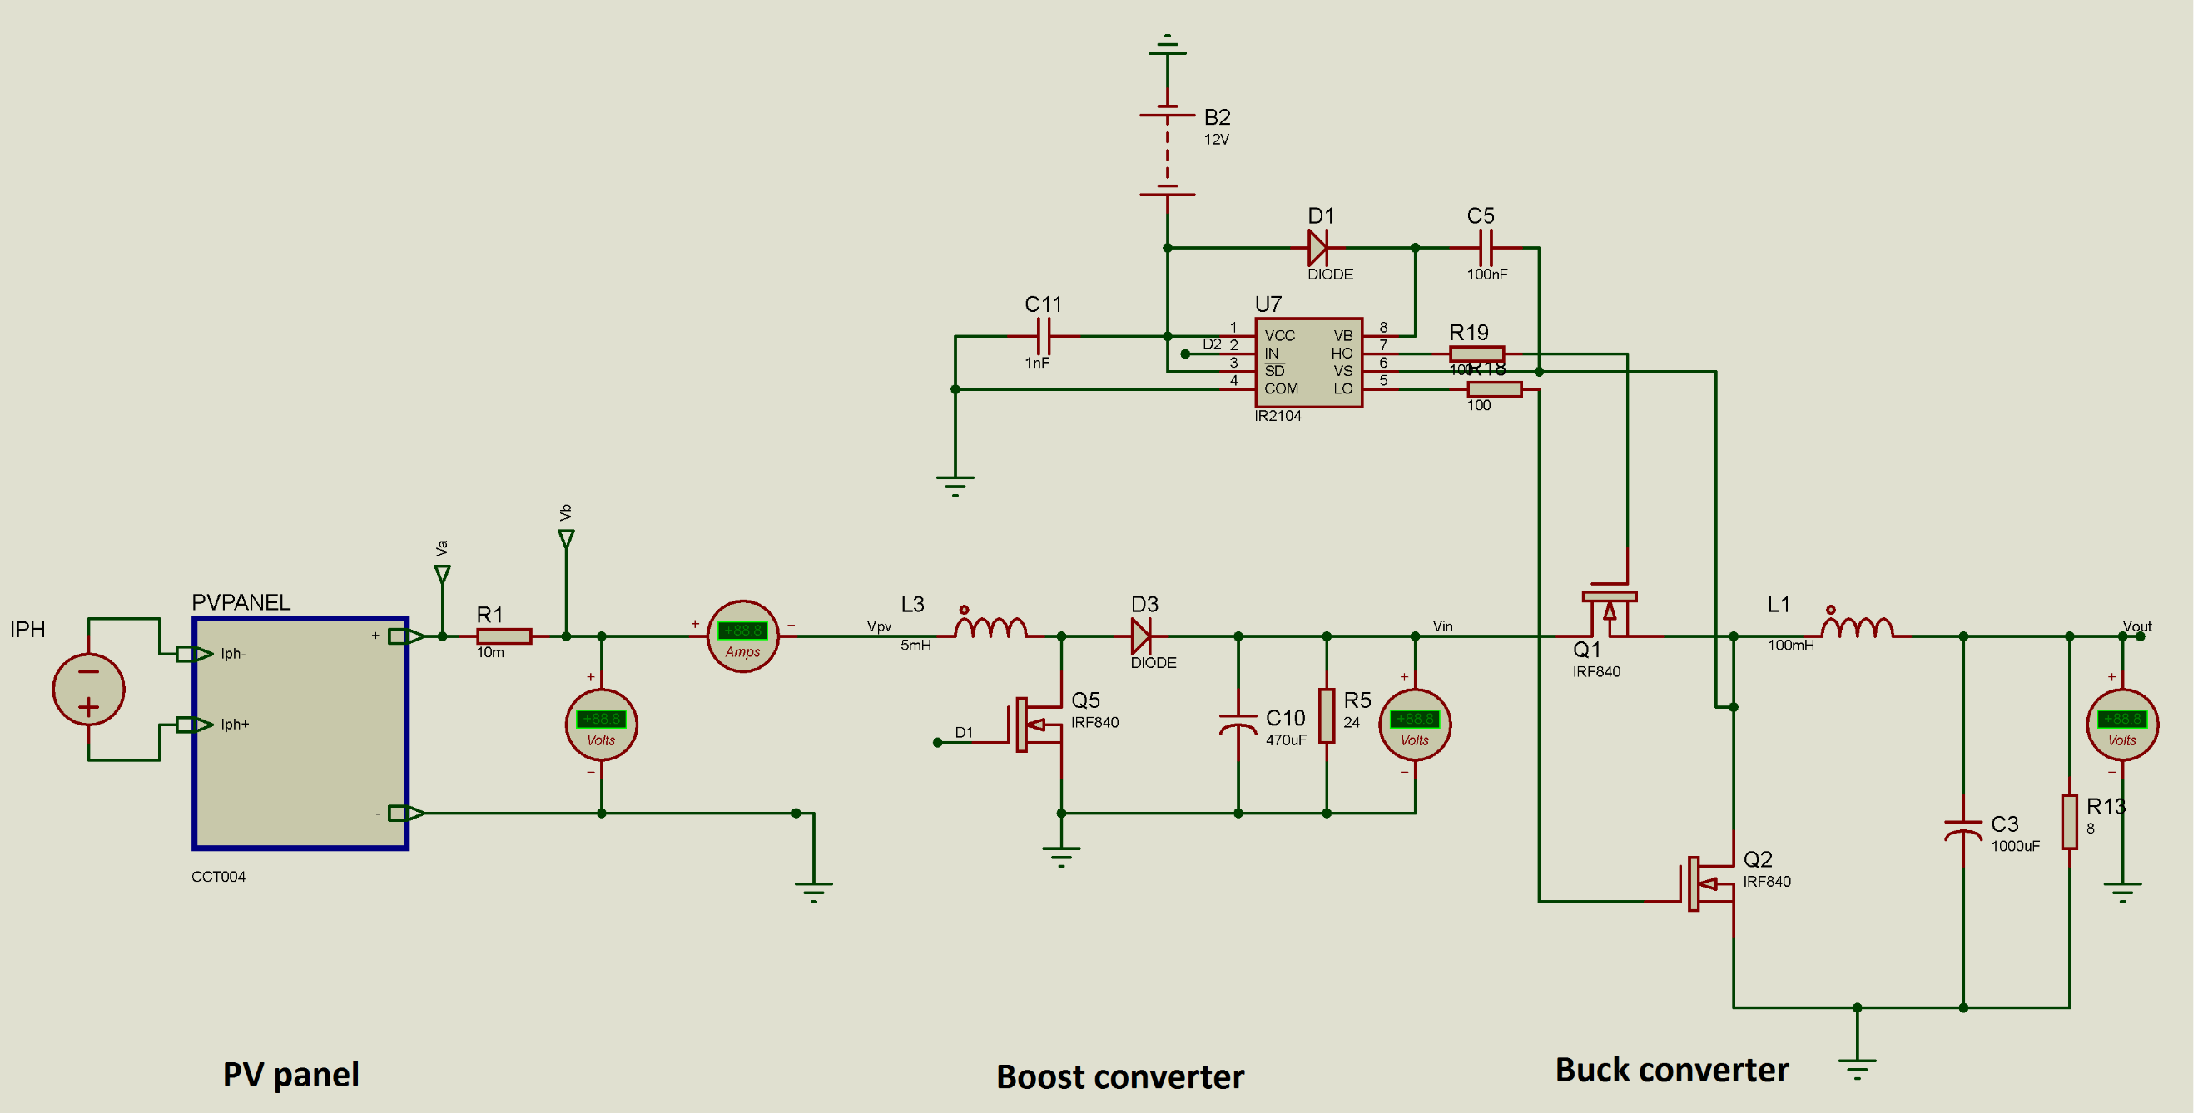

Figure 9: Schematic diagram of simulation circuit

* 1. *Simulation results*

For a stand alone solar system (without any MPPT block), when the environment is set at t = 25oC, the photo-generated current in the PV module Iph= 3.8128, the ideality factor A = 0.9784, the equivalent parallel resistance Rsh= 153.5644, the equivalent series resistance Rs= 0.38572, the output power is recorded as in Figure 4, with the maximum power is approximately 60W. When connecting the MPPT block, the circuit can be able to extract the peak power of 60W then oscillate slightly around that point, which is illustrated in Figure 9. This fact confirmed our algorithm.

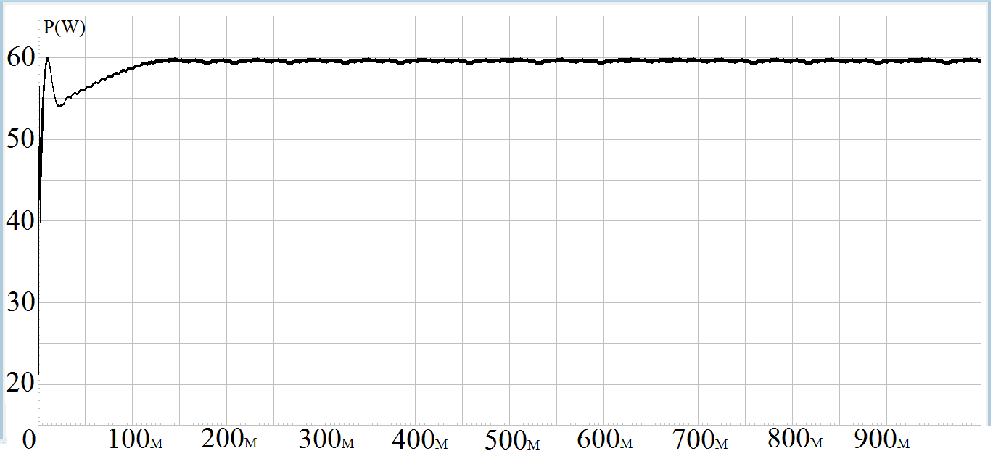

Figure 10: Maximum power extracted from simulation

While the circuit works at its MPP, an adaptive load allows us to track the output voltage according to a reference. In this part, a simple control law is implemented. The instantaneous output voltage is sensed and compared with a predefined reference. Then a feedback law is designed to allow the output voltage track along the reference. In this research, we set the desired voltage 12V and 24V, as it is the standard for DC power supply. The results are presented in Figure 10 and Figure 11. After about 500ms, it is able to track well the reference voltage. The total harmonics distortion (THD) in both cases are smaller than 5%.

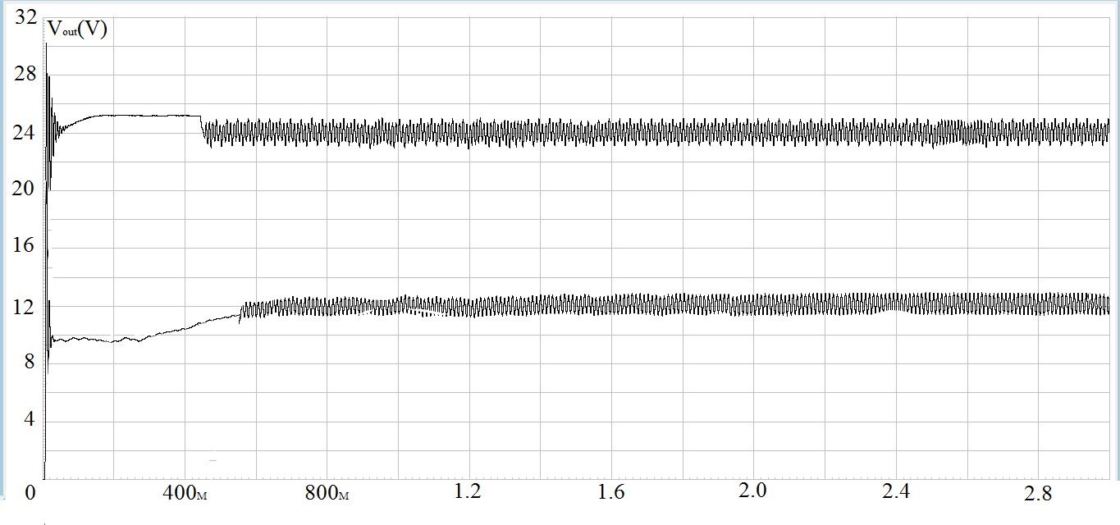

Figure 11: 12V-24V DC output voltage

1. **Conclusion**

The paper has successfully simulated the whole PV panel system in Proteus, which can both work at its most efficiency and provide a desired steady output. The output power from the solar panel is extracted through a converter and is kept at its maximum power point via a simple control algorithm. If the output power is in reduction direction compared with previous point, the system hold the previous point as the current power point. Otherwise, if it is in increasing direction, the system updates the current power status as the instantaneous power. This most efficient output power from the solar panel is fed into another converter to get a desired output voltage. The THD of the output voltage is smaller than 5%. For future research, the MPPT algorithm can be improved using more modern techniques, which includes optimization tools in order to get more robust and exact results. The output voltage may take less time to the steady state by using more complex control law.

**Acknowledgement**

This work has been supported by VNU University of Engineering and Technology under project number CN18.02.

# References

|  |  |
| --- | --- |
| [1] | A. Altamimi and Z. A. Khan, "A DC-DC buck converter with maximum power point tracking implementation for photovoltaic module application," in *IEEE Conference on Energy Conversion (CENCON)*, Kuala Lumpur, Malaysia, 2017. |
| [2] | N. Femia, G. Petrone, G. Spagnuolo and a. M. Vitelli, "Optimization of perturb and observe maximum power point tracking method," *IEEE Transactions on Power Electronics,* vol. 20, no. 4, pp. 963-973, 2005. |
| [3] | Z. Salam, J. Ahmed and a. B. S. Meguru, "The application of soft computing methods for MPPT of PV system: A technological and status review," *Applied Energy,* vol. 107, pp. 135-148, 2013. |
| [4] | N. J. James, K. B. Jayakrishnan, S. Umashankar, D. Vijayakumar and D. P. Kothari, "Perturb and observe MPPT algorithm for solar PV systems-modeling and simulation," in *2011 Annual IEEE India Conference*, Hyderabad, India, 2011. |
| [5] | A. Chandwani and A. Kothari, "Design, simulation and implementation of Maximum Power Point Tracking (MPPT) for solar based renewable systems," in *International Conference on Electrical Power and Energy Systems (ICEPES)*, Bhopal, India, 2016. |
| [6] | E. Bianconi, J. Calvente, R. Giral, E. Mamarelis and G. Petrone, "Perturb and Observe MPPT algorithm with a current controller based on the sliding mode," *International Journal of Electrical Power & Energy Systems,* vol. 44, no. 1, pp. 346-356, 2013. |
| [7] | T. D. a. R. K. Tekeshwar Prasad Sahu, "Simulation and Analysis of Perturb and Observe MPPT Algorithm for PV Array Using CUK Converter," *Advance in Electronic and Electric Engineering,* vol. 4, no. 2, pp. 213-224, 2014. |
| [8] | R. I. Putri, S. Wibowo and M. Rifai, "Maximum Power Point Tracking for Photovoltaic Using Incremental Conductance Method," *Energy Procedia,* vol. 68, pp. 22-30, 2015. |
| [9] | R. Roshan, Y. Yadav, S. Umashankar, D. Vijayakumar and D. P. Kothari, "Modeling and simulation of Incremental conductance MPPT algorithm based solar Photo Voltaic system using CUK converter," in *International Conference on Energy Efficient Technologies for Sustainability*, Nagercoil, India, 2013. |
| [10] | M. I. Bahari, P. Tarassodi, Y. M. Naeini, A. K. Khalilabad and P. Shirazi, "Modeling and simulation of hill climbing MPPT algorithm for photovoltaic application," in *International Symposium on Power Electronics, Electrical Drives, Automation and Motion (SPEEDAM)*, Anacapri, Italy, 2016. |
| [11] | R. Rawat and S. Chandel, "Hill climbing techniques for tracking maximum power point in solar photovoltaic systems - A review," *Journal of Sustainable Development and Green Economics (IJSDGE),* vol. 2, no. 1, pp. 90-95, 2013. |
| [12] | T. A. Vu and D. P. N. a. P. T. V. Huong, "Analysis and Control Design of Transformerless High Gain, High Efficient Buck-boost DC-DC Converters," in *EEE International Conference on Sustainable Energy Technologies (ICSET)*, Hanoi, Vietnam, 2016. |
| [13] | D. P. Nam, T. A. Vu, N. V. Quyen, N. T. V. Huong and P. T. V. Huong, "Robust control for buck converter based on optimization," in *International Conference on System Science and Engineering (ICSSE)*, Ho Chi Minh City, Vietnam, 2017. |
| [14] | H. Pham, H. Jung and T. Hu, "Ripple reduction in AC-DC power converters via a Lyapunov approach," in *Proceedings of the American Control Conference*, Montreal, Canada, 2012. |
| [15] | H. Pham, H. Jung and T. Hu, "State-Space Approach to Modeling and Ripple Reduction in AC–DC Converters," *IEEE Transactions on Control Systems Technology,* vol. 21, no. 5, pp. 1949 - 1955, 2013. |
| [16] | T. Salmi, M. Bouzguenda, A. Gastli and A. Masmoudi, "MATLAB/Simulink Based Modelling of Solar Photovoltaic Cell," *International Journal of Renewable Energy Research,* vol. 2, no. 2, 2012. |
| [17] | F. A. Salem, "Modeling and Simulation issues on PhotoVoltaic systems, for Mechatronics design of solar electric applications," *IPASJ International Journal of Mechanical Engineering,* vol. 2, no. 8, pp. 024-047, 2014. |
| [18] | R. Prakash and S. Singh, "Designing and Modelling of Solar Photovoltaic Cell and Array," *IOSR Journal of Electrical and Electronics Engineering (IOSR-JEEE),* vol. 11, no. 2, pp. 35-40, 2016. |
| [19] | L. Liu and L. A. C. Lopes, "An improved perturbation and observation maximum power point tracking algorithm for PV arrays," *PESC Record - IEEE Annual Power Electronics Specialists Conference,,* vol. 3, pp. 2005-2010, 2004. |
| [20] | M. B. K. a. M. J. Y. I. S. Kim, "New maximum power point tracker using sliding-mode observer for estimation of solar array current in the grid-connected photovoltaic system," *IEEE Trans. Ind. Electron.,* vol. 53, no. 4, pp. 1027 - 1035, 2006. |
| [21] | B. S. a. G. V. E. S. Kumar, "A comparative study of different MPPT techniques using different DC-DC converters in a standalone PV system," *IEEE Region 10 Annual International Conference, Proceed- ings/TENCON,* pp. 1690 - 1695, 2017. |
| [22] | A. R. Reisi, M. H. Moradi and a. S. Jamasb, "Classification and comparison of maximum power point tracking techniques for photo- voltaic system: A review," *Elsevier,* 2013. |
| [23] | K. I. a. Z. Salam, "A review of maximum power point tracking techniques of PV system for uniform insolation and partial shading condition," *Renew. Sustain. Energy Rev.,* vol. 19, pp. 475 - 488, 2013. |
| [24] | P. Sivakumar, A. A. Kader, Y. Kaliavaradhan and a. M. Arutchelvi, "Analysis and enhancement of PV efficiency with incremental conduc- tance MPPT technique under non-linear loading conditions," *Renew. Energy,* vol. 81, pp. 543 - 550, 2015. |
| [25] | R. I. Putri, S. Wibowo and a. M. Rifai, "Maximumpowerpointtrackingfor photovoltaic using incremental conductance method," *Energy Procedia,* vol. 68, pp. 22 - 30, 2015. |

1. *Corresponding author’s email: huongpv@vnu.edu.vn