Improved Particle Swarm Optimization of Three-Dimensional Path Planning for Fixed Wing Unmanned Aerial Vehicle

Quang-Huy Vuong¹, Giang Thi-Huong Dang², ﻿Minh Hoàng Hà¹, Minh-Trien Pham¹
¹University of Engineering and Technology, Vietnam National University, Hanoi, Vietnam; ²University of Economic and Technical Industries;
Abstract
Path planning for Unmanned Aerial Vehicle (UAV) targets at generating an optimal global path to the target, avoiding collisions and optimizing the given cost function under constraints. In this paper, the path planning problem for UAV in pre-known 3D environment is presented. Particle Swarm Optimization (PSO) was proved the efficiency for various problems. PSO has high convergence speed yet with its major drawback of premature convergence when solving large-scale optimization problems. In this paper, the improved PSO with adaptive mutation to overcome its drawback in order to applied PSO the UAV path planning in real 3D environment which composed of mountains and constraints. The effectiveness of the proposed PSO algorithm is compared to Genetic Algorithm, standard PSO and other improved PSO using 3D map of Daklak, Dakrong and Langco Beach. The results have shown the potential for applying proposed algorithm in optimizing the 3D UAV path planning.
Keywords: UAV, Path planning, PSO, Optimization.

1. Introduction*
An Unmanned Aerial Vehicle (UAV) is designed for the applications such as inspection, monitoring, and dangerous missions. Today, there is the large interest worldwide in the development of UAV for the number of smart agricultures, environment monitoring, border patrol, disaster assistance and many others. Whenever a mission is defined, path planning is the crucial element of whole system. In general, path planning targets at generating an optimal global path to the target, avoiding collisions with obstacles, and optimizing the given cost function under constraints.
Simple 2D path planning algorithm is not able to deal with complex 3D environment, where there are quite a lot of structures constraints and uncertainties. Therefore, in the 3D environment the 3D path planning algorithm for UAV navigation are urgently need nowadays, especially in complex environments such as forest, cave, and urban areas as shown in Figure 1.
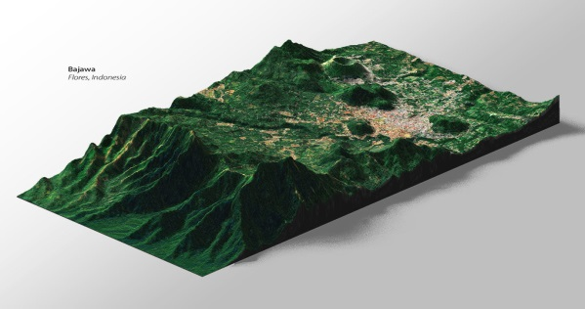
Figure 1. Example of 3D environment
Scholars have done a great deal of success in path planning to solve such problems such as: 3D Voronoi [1], Probabilistic Roadmap Method [2]. There are some useful optimal search algorithms such as A* [3] or D* [4]. These researches are only focus on some methods that are broadly used and not conducive to solve complicated problem because of great computation time and data size [5]. On applying bio-inspired planning algorithms, as in [6] Genetic Algorithm was applied, in [7], [8] Particle Swarm Optimization was improved, Differential Evolution was also proposed in [9], etc. These are algorithms with high efficiency in finding the optimal solution of the problems.
﻿PSO is well known for its lower computational costs, simple principle, higher efficiency and widely used to solve path planning problems [10]. However, PSO has the drawback of a premature convergence when solving complicated optimization problems [11]. Therefore, this research puts forward an improved PSO algorithm by adding adaptive mutation step to optimize the trajectory of UAV.
The rest of this paper is organized as follows. Section 2 provides the techniques to represent the environment and trajectory of UAV and the cost function. Section 3 provides bio-inspired algorithm PSO and improved one. Experimental results and discussions are presented in Section 4 to evaluate the effectiveness of optimization algorithms. Finally, we conclude the paper in Section 5.
2. Environment and cost function modeling
For pre-known 3D path planning, the world space is discretized to represent the 3D environment. The environment, trajectory, obstacle will be defined as following.
2.1. Environment and trajectory modeling
﻿In this work, the planning problem was determined in three-dimensional space. The representations of the workspace and trajectory are generally the first step of path planning process for UAV. To apply optimization algorithms to the trajectory planning problem, the environment is encoded into a representation which is suited for UAV’s path and algorithms. In this phase, the 2D grid is created where each element of the matrix specifies the elevation of terrain [12]. Environment and path representations are shown in Figure 2.
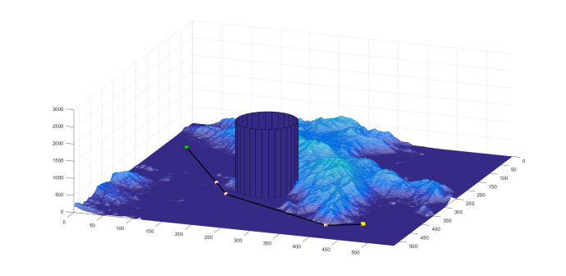
Figure 2. 3D visualization of environment and trajectory
﻿In Figure 2, the circle markers represent the way-points of the UAV path, the black line connecting the way-points represents the trajectory of an UAV and the blue cylinders represent the cylindrical danger zones to be avoided.
﻿The final trajectory is created by connecting all the way-points. A matrix is used where each row represents the coordinates of i-th way-points, as shown in (1).
$trajectory=\left[\begin{aligned}\begin{matrix}x_{1} & y_{1} & z_{1}\end{matrix} \\ \begin{matrix}x_{2} & y_{2} & z_{2}\end{matrix} \\ \begin{matrix}… & … & …\end{matrix} \\ \begin{matrix}x_{n} & y_{n} & z_{n}\end{matrix}\end{aligned}\right]$ (1)
2.2. Cost function and constraints modeling
﻿The danger zones are kept in sub-matrices where each row represents the coordinates (x_{i},y_{i}) and d_{i} is the diameter of the i-th cylinder. The danger zone is defined as follows:
$danger zones=\left[\begin{aligned}\begin{matrix}x_{1} & y_{1} & d_{1}\end{matrix} \\ \begin{matrix}x_{2} & y_{2} & d_{2}\end{matrix} \\ \begin{matrix}… & … & …\end{matrix} \\ \begin{matrix}x_{n} & y_{n} & d_{n}\end{matrix}\end{aligned}\right]$ (2)
﻿The path planning problem is formulated as an optimization of the following cost function including path length, flight altitude, collision and danger zones avoidance. With assumption of having enough fuel, the cost function in [12] is simplify as:
$F_{cost} = F_{length}+F_{altitude} + F_{collision}+ F_{danger zones}$ (3)
where F_{length} and F_{altitude} denote the terms of path length and UAV fly height to evaluate a candidate route, respectively. F_{collision} penalizes paths colliding with the ground and F_{dangerzones} is the penalty term while paths going through danger zones.
It is believed that the length of an optimal route should be as short as possible. Then F_{length} can be written as follows:
$F_{length}=1-\left(\frac{L_{P1P2}}{L_{traj}}\right)$$C_{length}=1-\left(\frac{L_{P1P2}}{L_{traj}}\right)$ (4)
therefore
$F_{length}∈\left[0,1\right]$ (5)
where $L_{P_{1}P_{2}}$ is distance of the straight line from the starting point to the destination point and L_{traj} is the total length of the actual trajectory.
It is obviously that the UAV should fly as low altitude as possible, but the decrease of the altitude will increase the crash probability with the ground and mountain. The flight altitude cost function of the path is defined as follows:
$F_{altitude}=\frac{A_{traj}-Z_{min}}{Z_{max}-Z_{min}}$ (6)
therefore
$F_{altitude}∈[0,1]$ (7)
﻿where Z_{max} is the upper bound of the height in our search space, Z_{min} is the lower bound and A_{traj} is the average altitude of the actual trajectory. Z_{max} and Z_{min} are respectively set to be slightly above the highest and lowest points of the terrain.
As flying into the danger zones with the missile and radar, the UAV may encounter the risk of being discovered and attacked from the enemies. The term used to penalize the violation of UAV to the danger zones is defined as follows:
$F_{danger zones}=\frac{L_{inside d.z}}{\sum_{i=1}^{n}{d_{i}}}$ (8)
with
$F_{danger zones}∈[0,1]$ (9)
﻿where n is the total number of danger zones, L_{inside_d.z} is the path length into the threat sources zones for a route and d_{i} is the diameter of the i-th danger zone. Since it is possible for L_{inside_d.z} to be larger $\sum_{i=1}^{n}{d_{i}}$ (as in the case of a dog-leg path through a single danger zone), $F_{danger zones}$ is set to 1.
In order to avoid the collision with the mountain and ground in the environment, the flight altitude should be higher than the elevation of the terrain. This function is depicted as:
$F_{collision}=\left\{\begin{aligned}0 , L_{under terrain}=0 \\ P+\left(\frac{L_{under terrain}}{L_{traj}}\right), L_{under terrain}>0\end{aligned}\right.$ (10)
with
$F_{collision }ϵ 0∪[P,P+1]$ (11)
﻿where $L_{under terrain}$ is the total length of the trajectory which travels below the ground level and $L_{traj}$ is the total length of the trajectory. For this function, additional penalty term P is set to be 3. Therefore, when the value of the evaluation function F is greater than 3.5, the planning path can be considered as a non-feasible one. The altitude of the terrain and the altitude of the trajectory are compared in a discreet way using the Bresenham’s line drawing algorithm [13].
After determining the cost function, optimization algorithms will be used to find the optimal path by minimizing the cost value. The optimal trajectory satisfies four criteria that are represented by the cost function.
3. ﻿Improved particle swarm optimization
﻿PSO is a population based stochastic optimization technique that finds optimal root by updating generations [14]. PSO simulates the food searching behavior of fish herd or bird flock. In the PSO, each particle of swarm always searches in its searching space to replace old position with the new best position. The searching process using PSO includes four steps (except step four) and improved PSO includes five steps as described below:
﻿ 1. Initialize: Generate the population and evaluate the objective (fitness) function.
2. Update personal best and global best: Check each particle for new personal best. If the current position is better than personal best, it becomes personal best. Otherwise, the personal best remains the same. If any particle in the swarm holds a personal best that is better than global best, it becomes leader and its personal best becomes global best.
3. Update velocity and position of all particles: The position and velocity are updated using the following equations:
$v_{i}\left(t\right)=wv_{i}(t-1)+a_{1}u_{d}{(p}_{i}(t-1)-x_{i}(t-1))+a_{2}U_{d}(g(t-1)-x_{i}(t-1))$ (12)
${x_{i}\left(t\right)=x}_{i}\left(t-1\right)+v_{i}\left(t\right)∆t$ (13)
in which $v_{i}$ is the velocity of the i-th particle; $x_{i}$ is its position in search space; $p_{i}$ is the personal best of i-th particle; $g$ is the global best of the swarm; $u_{d}$ and $U_{d}$ are random values in the range of [0,1]; $w$, $a_{1}$, $a_{2}$ are respectively inertia, personal influence and social influence parameters.
4. Adaptive mutation: The position of particle $x_{i}$ will be mutated by using Gaussian mutation as:
${x^{*}}_{i}\left(t\right)=x_{i}\left(t\right)*(1+m*gaussian(σ))$ (14)
in which ${x^{*}}_{i}\left(t\right)$ is a particle after the mutation, $σ$ is set to 10% of search space, $m=1/t$ is the adaption coefficient which decreasing by the number of iterations. Compared with adaptive mutation in [15], [16], the effect of mutation is controlled by m for fine turning when particle reach global optimal and overcome the local optimal.
5. Terminate searching process or continue searching: The process is terminated if i) The current step is equal to latest step or ii) The swarm has converged (radius of the swarm is smaller than ${10}^{-3}\%$ of search space size). Otherwise, come back to step 2.
The flowchart of standard PSO and Improved PSO with adaptive mutation is shown in Figure 3.
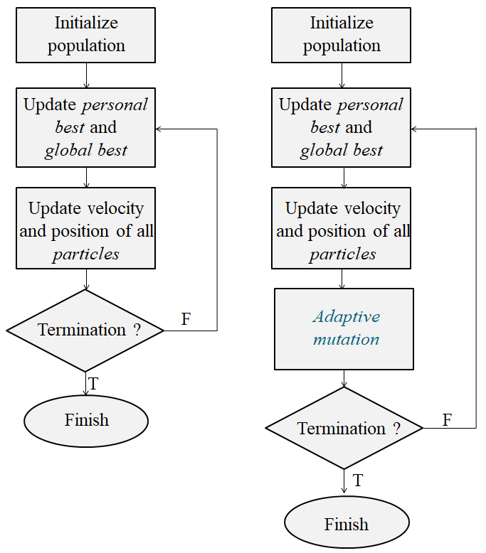
Figure 3. The proposed PSO algorithm
4. Experimental results
﻿In this section, simulation results are presented using the proposed approach. We compare the performance of the four algorithms using different scenarios of three real terrain elevation maps from Vietnam (Daklak, Dakrong and Langco Beach). The digital elevation maps for the three real terrains were taken from The Global Data Explorer repository [17] to satisfy real environment requirements. All environments have been chosen in order to search for path lines between mountains, plains and sea. In addition, some danger zones are randomly set to increase the complexity of environment. 3D visualizations of the computed paths of three terrains are shown in Figure 4 and parameters of them are shown in Table 1.
Table 1. Parameters of Daklak, Dakrong and Langco maps
Map | Area  (km) | Min-Max altitude (km)
Daklak | 16.32×15.4 | 9.33-33.42
Dakrong | 19.59×20.1 | 0.09-28.08
Langco | 15.72×16.02 | 0-38.1
In order to illustrate the superiority of the improved algorithm, the comparison simulation was conducted between the proposed Improved PSO algorithm with adaptive mutation and Improved PSO in [8]. In this reference, authors added a method to dynamically adjust the inertia weight factor ω and the personal influence $a_{1}$ and social influence $a_{2}$ parameters according to the change of the search process. Figure 5 show the cost value comparison curve of the two algorithms.
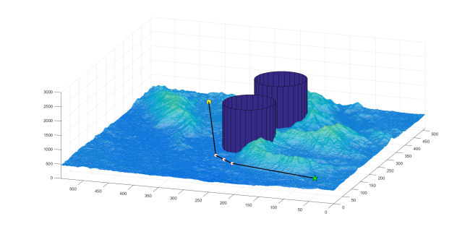
- Daklak
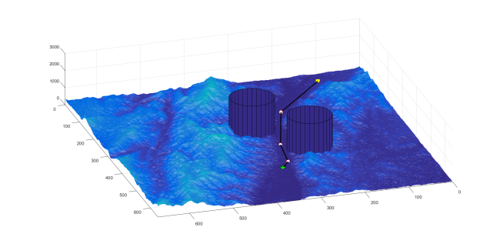
- Dakrong
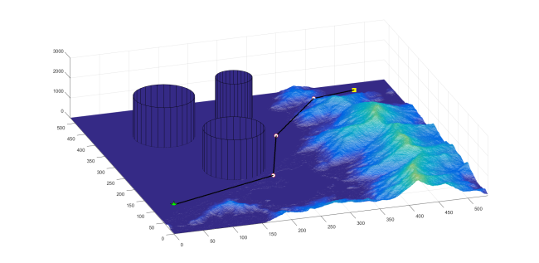
- LangCo
Figure 4. Optimal path planning of three maps
﻿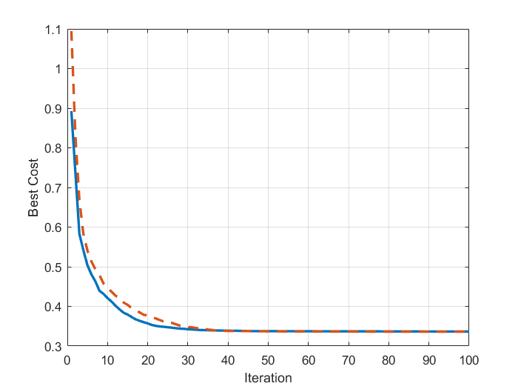
- Daklak
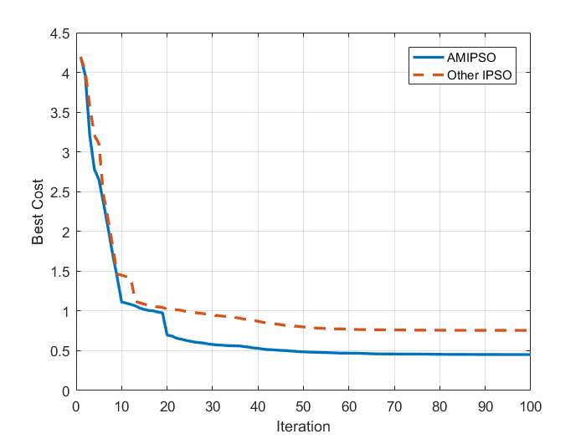
- Dakrong
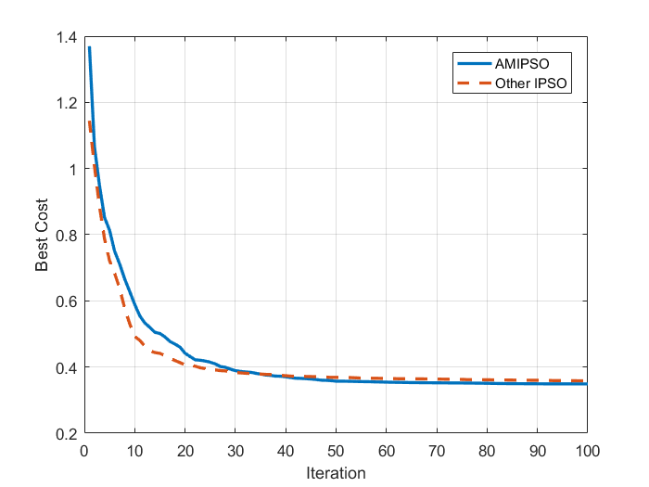
- Langco

Figure 5. Comparision of cost function for 3 maps
All of four algorithms (GA, PSO, proposed Improved PSO and Improved PSO) have been tested under three different scenarios. In each terrain, each algorithm is run 10 times and we calculate the cost function average and standard deviation. A solution is considered better than others if its cost function is smaller. A stable algorithm should have lower cost function standard deviation. The cost values obtained by running four optimization algorithms are shown in Table 2.
Table 2. Resutls
Terrain | Cost value $±$ standard deviation
 | GA | PSO | PSO in [8] | Improved PSO
Daklak | 0.3381$±$0.0007 | 0.3562$±$0.0012 | 0.3363$±$0.0001 | 0.3366$±$0.0001
Dakrong | 1.5707$±$3.4002 | 1.3245$±$2.2532 | 0.7547$±$1.1049 | 0.4527$±$1.0193
LangCo | 0.3856$±$0.0015 | 0.3964$±$0.0021 | 0.3548$±$0.0002 | 0.3546$±$0.0002
In Table 2, it is shown that standard PSO algorithm does not performs better than GA in most cases, but the improved PSO with adaptive mutation algorithm shows significantly more efficiency, demonstrating the reliability of the algorithm for applying to practical problems.

Once optimal position is detected, population is moved to exploit local optimal solution. Improved PSO in [8] features better search efficiency than standard PSO and GA because of randomized search ability by adjusting ω, $a_{1}$ and $a_{2}$ parameters. Search space will be better explored and exploited and convergence speed is also reduced by using this approach. However, after each generation, if no particle of swarm shows any significant progress in solution, there is no improving of fitness function value. Then, PSO, GA or Improved PSO in [8] can be easily trapped in local optimums because of many local optimal traps in complex search space like Langco. Therefore, it is more difficult to find the global optimal solution. In comparison to other improved PSO algorithm in [8], Improved PSO with adaptive mutation is not too superior and efficiency is quite similar in Daklak and Langco maps.
However, for applying in difficult scenario of Langco, Improved PSO with adaptive mutation performs much better and this result shows the effectiveness of the proposed algorithm. Proposed algorithm was able to perform better than other algorithms. Adaptive mutation can maintain the population diversity throughout the algorithm run by changing position of particles using Gaussian mutation. Compared to classical version of PSO, GA and Improved PSO in [8], proposed Improved PSO is more powerful at jumping out local optimums as well as improving the algorithm convergence ability effectively.
5. Conclusion
﻿In this research, offline UAV path planning problem which need considering a real 3D environment and known obstacles is tackled. Meta-heuristic approaches (GA, standard PSO and improved PSO) were used to optimize the trajectory. It is practically proved that improved PSO produces better path and especially has dominant stability compared to the others. With such a high stability of improved PSO, we expect it will also perform well in more complex path planning problem. In future research, the smooth constraint will be considered for smooth trajectory.
Acknowledgement
This research is funded by the Vietnam National Foundation for Science and Technology Development (NAFOSTED) under grant number 102.99-2016.21.
References
[1] L. Liu and S. Zhang, “Voronoi diagram and GIS-based 3D path planning,” in 2009 17th International Conference on Geoinformatics, Geoinformatics 2009, 2009.
[2] F. Yan, Y. S. Liu, and J. Z. Xiao, “Path planning in complex 3D environments using a probabilistic roadmap method,” Int. J. Autom. Comput., vol. 10, no. 6, pp. 525–533, 2013.
[3] L. De Filippis, G. Guglieri, and F. Quagliotti, “Path planning strategies for UAVS in 3D environments,” J. Intell. Robot. Syst. Theory Appl., vol. 65, no. 1–4, pp. 247–264, 2012.
[4] J. Carsten, D. Ferguson, and A. Stentz, “3D field D*: improved path planning and replanning in three dimensions,” IEEE Int. Conf. Intell. Robot. Syst., pp. 3381–3386, 2006.
[5] L. Yang, J. Qi, J. Xiao, and X. Yong, “A literature review of UAV 3D path planning,” Proc. World Congr. Intell. Control Autom., vol. 2015-March, no. March, pp. 2376–2381, 2015.
[6] Y. V. Pehlivanoglu, O. Baysal, and A. Hacioglu, “Path planning for autonomous UAV via vibrational genetic algorithm,” Aircr. Eng. Aerosp. Technol., vol. 79, no. 4, pp. 352–359, 2007.
[7] Y. Bao, X. Fu, and X. Gao, “Path planning for reconnaissance UAV based on particle swarm optimization,” in 2010 2nd International Conference on Computational Intelligence and Natural Computing, CINC 2010, 2010.
[8] Z. Cheng, E. Wang, Y. Tang, and Y. Wang, “Real-time Path Planning Strategy for UAV Based on Improved Particle Swarm Optimization,” J. Comput., 2014.
[9] I. K. Nikolos and A. N. Brintaki, “Coordinated UAV Path Planning Using Differential Evolution,” in Proceedings of the 2005 IEEE International Symposium on, Mediterrean Conference on Control and Automation Intelligent Control, 2005., 2005, vol. 5, no. 3, pp. 549–556.
[10] Y. Zhang, L. Wu, and S. Wang, “UCAV path planning by Fitness-scaling Adaptive Chaotic Particle Swarm Optimization,” Math. Probl. Eng., 2013.
[11] H. Huang, L. Lv, S. Ye, and Z. Hao, “Particle swarm optimization with convergence speed controller for large-scale numerical optimization,” Soft Comput., 2019.
[12] V. Roberge, M. Tarbouchi, and G. Labonte, “Comparison of parallel genetic algorithm and particle swarm optimization for real-time UAV path planning,” IEEE Trans. Ind. Informatics, vol. 9, no. 1, pp. 132–141, 2013.
[13] J. E. Bresenham, “Algorithm for computer control of a digital plotter,” IBM Syst. J., 2010.
[14] B. Chopard and M. Tomassini, An Introduction to Metaheuristics for Optimization. 2018.
[15] T. Jun and Z. Xiaojuan, “Particle swarm optimization with adaptive mutation,” in 2009 WASE International Conference on Information Engineering, ICIE 2009, 2009.
[16] C. Li and L. Le, “An Adaptive Mutation Operator for Particle Swarm Optimization,” Comput. Intell., 2008.
[17] “Global data explorer.” [Online]. Available: https://gdex.cr.usgs.gov/gdex/.
[18] Z. Cheng, E. Wang, Y. Tang, and Y. Wang, “Real-time Path Planning Strategy for UAV Based on Improved Particle Swarm Optimization,” J. Comput., vol. 9, no. 1, pp. 209–214, 2014.

* Corresponding author. E-mail.: trienpm@vnu.edu.vn

