Binh-Duong Tran¹, Wenyuan LI¹, Trong Hieu Le¹, Tuan-Viet Duong¹,
Quynh Tran Thi Thuy², Duc-Tan Tran²
¹School of Information Science and Engineering, Southeast University, Nanjing, China
²VNU University of Engineering and Technology

A simple Triple-band Filter for Wireless Communication Applications

Abstract – This paper proposes a simple microstrip triple-band filter for 2GHz/2.5GHz/3.5GHz band applications. The filter is designed based on combining a novel cross-shaped stub loaded resonator and a traditional half wavelength resonator to achieve multi-band and high selectivity. The position of each passband can be independently corrected by properly changing the lengths of microstrip lines, respectively. A triple-band microwave filter prototype has been fabricated and tested. The experiment results match well with the simulation results.
Index Terms – microstrip BPF, multi-band, stub loaded resonators, half wavelength resonator.

Introduction

The modern wireless communication systems have been constantly evolving with various new standards. The ones are usually intergrated with the previous standards in a single device. For examples, a smart phone includes many wireless applications, such as 2G, 3G, 4G, WLAN, RFID, WiMAX, Bluetooth, GPS, etc. So, designing of multi-band components, such as antennas, amplifiers, mixers, filters are necessary [1-4]. This paper focuses on designing and implementing a high performance triple-band microstrip Band Pass Filter (MB-BPF). The important characteristics of a MB-BPF are high selectivity, low return loss, independently tuned bands, compact, low cost, and easy integration [5]. In the literature, theory of microstrip MB-BPFs are almost based on resonators. In [6, 7], a dual band filter is designed by exploiting the dual mode of resonance but the proposed structure is complicated. The resonators with open loop, open stubs, stepped impedance structures are used popularly in designing of MB-BPFs [8, 9, 10-14]. However, the designs are exceedingly large and the adjustment of frequency of each individual band is difficult.
In this paper, we propose a simple triple-band filter which includes inner open rectangular resonators and proposed ones which combine a cross-shaped stub loaded resonator and a half wavelength resonator. The frequency response of the filter has achieved three different passbands independently controlled within range at 1.8~2.2 GHz ($f_{01 }$) for 3G/4G, 2.4~2.7 GHz ($f_{02}$) for WiFi/RFID/Bluetooth, and 3.4~3.6 GHz ($f_{03 }$) for 4G/WiMAX applications.
The paper is organized as follows. The theory of the filter is explained in section 2. Then, the proposed filter is simulated with the HFSS software and fabricated with the low cost 2-layer PCB technology. The simulation and implementation results are shown in section 3 and section 4, respectively. And the last section is conclusions.

CONFIGURATION OF FILTER
The layout of the proposed filter is shown in Fig.1. It has several outstanding features such as: three bands, independently adjusted passbands, high selectivity, compact, simple, and low-cost. The microstrip filter is designed on a substrate with a relative dielectric constant of 2.2, thickness of 0.508 mm and loss tangent of 0.0009.
As shown in Fig. 1, the filter consists of the outer and the inner resonators. The former are cross-shaped stub loaded rectangular resonators and the latter are half wavelength resonators. The folded open-loop structure is used for the coupling of the RF signals among resonators which makes the circuit compact.
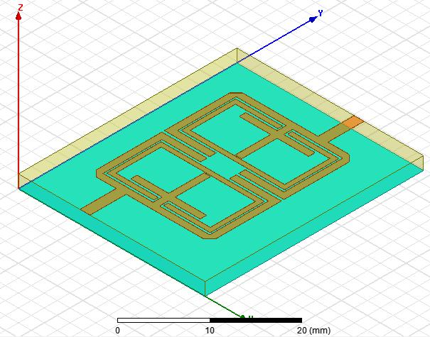

Fig.1. Configuration of the proposed filter
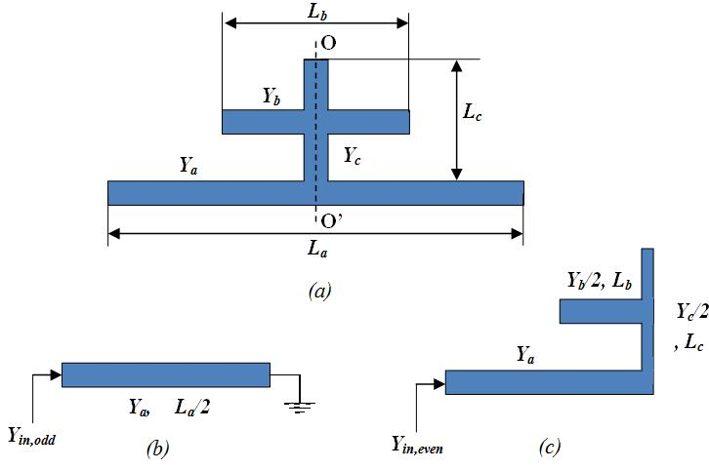

Fig. 2. (a) The structure of the crossed-shape stub loaded resonator;

(b) Odd mode equivalent circuit; (c) Even mode equivalent circuit

A. The cross-shaped stub loaded resonator
The proposed cross-shaped stub loaded resonator is a variation of the open-stub loaded resonator. As shown in Fig. 2a, the structure is symmetrical in nature (Fig.2a), so that the even and odd mode analysis can be applied for the resonator [12]. Fig. 2b and Fig. 2c show equivalent circuit of the one in odd and even mode, respectively.

Odd mode analysis
The RF signals coming into two symmetrical parts have equal magnitudes and opposite signs. As a result, the achieved zero-voltage at plane O-O’ causes a symmetrical point implying short-circuit as shown in Fig.2b. Therefore, the input admittance is given by:

 | $$Y_{in, odd}=\frac{Y_{a}}{jtan\left(\frac{θ_{a}}{2}\right)}$$ | (1)
where $Y_{a}$ is the characteristic admittance and $θ_{a}$ is the electrical length of the microstrip line which has physical length of $L_{a}$.
The resonance condition is $Y_{in,odd}=0$. Therefore, the fundamental resonant frequency for the odd mode is given by:
 | $$f_{odd}=\frac{\left(2n-1\right)c}{2L_{a }\sqrt{ε_{eff}}}$$ | (2)
where n = 1, 2,…, N is an integer which indicates harmonies of the filter, c is the light velocity in free space, and $ε_{eff}$ is the applied effective dielectric constant of the substrate material [13].
It is remarkable that the odd mode frequency does not depend on the length of cross-shaped stub ($L_{b } and L_{c}$).

Even mode analysis
From the even mode equivalent circuit of stub loaded resonator as shown in Fig.2c, the input admittance is given by:

 | $$Y_{in, even}=\frac{jY_{a}\left(\frac{2Y_{a}tan\left({θ_{a}}/2\right)+Y_{b}tanθ_{b}}{2Y_{a}-Y_{b}tan\left({θ_{a}}/2\right)tanθ_{b}}\right)+Y_{c}tan\left({θ_{c}}/2\right)}{1-j\left(\frac{2Y_{a}tan\left({θ_{a}}/2\right)+Y_{b}tanθ_{b}}{2Y_{a}-Y_{b}tan\left({θ_{a}}/2\right)tanθ_{b}}\right)Y_{a}Y_{c}tan\left({θ_{c}}/2\right)}$$ | (3)
where $θ_{b}$ and $θ_{c}$are the electrical lengths of the microstrip lines which have physical lengths of $L_{b}$ and $L_{c}$, respectively.

The resonance condition is $Y_{in,even}=0$. Hence the fundamental resonant frequency for even mode is given by:

 | $$f_{even}=\frac{nc}{\left(L_{a}+{2L}_{b}+L_{c}\right)\sqrt{ε_{eff}}}$$ | (4)
The equation (4) shows that the lengths of cross-shaped stub affect on the even mode frequency only. So, the resonant frequencies of the proposed resonantor can be adjusted independently to achieve desired individual passbands.

B. The half wavelength resonator
The half wavelength resonator is a simple structure which is described in [5] in details. The resonant frequency of the structure is calculated by:

$f_{r}=\frac{c}{2L\sqrt{ε_{eff}}}$ (5)

where L is the physical length of the resonator.

SIMULATION RESULTS

This section consists of designing three passbands of the filter and simulating the structure based on HFSS software. The structure with lengths of microstrip lines is shown in Fig. 3 in details. Input and output transmission lines of the filter have characteristic impedances 50Ω.

Passband Design
Desired resonant frequencies of the filter are calculated by:

${ f}_{01}=\frac{c}{2L_{a}\sqrt{ε_{eff}}}=\left(1.8\sim 2.2\right)GHz$ (6)
 | $$f_{02}=\frac{c}{2\left({2L}_{4}+L_{5}+{2L}_{6}\right)\sqrt{ε_{eff}}}=\left(2.4\sim 2.7\right) GHz$$ | (7)
 | $$f_{03}=\frac{c}{\left(L_{a}+{2L}_{7}+L_{8}\right)\sqrt{ε_{eff}}}=\left(3.2\sim 3.5\right) GHz$$ | (8)

where $L_{a}=L_{1}+{2L}_{2}+{2L}_{3}+d+w$ fixed at about 50 mm with the width of 1 mm.

The ${ f}_{01}, { f}_{02}, { f}_{03}$ frequencies are corresponding to elementary odd mode resonant frequency (Eq. 2), half wavelength resonant frequency (Eq. 5), and elementary odd mode resonant frequency (Eq. 4).

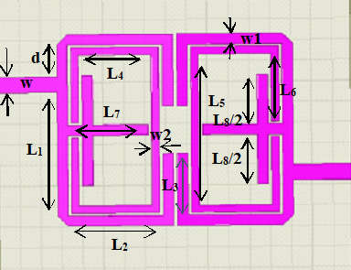
Fig. 3. Geometry of the proposed triple-band filter

Simulation Results
Simulation results of influence of L₃, L₆, and L₈ on frequency response of the filter are shown in Fig. 4, Fig. 5, and Fig. 6. In these figures, the solid lines with square, circle, and triangular marks present $f_{01}$, $f_{02}$, and $f_{03}$, respectively.

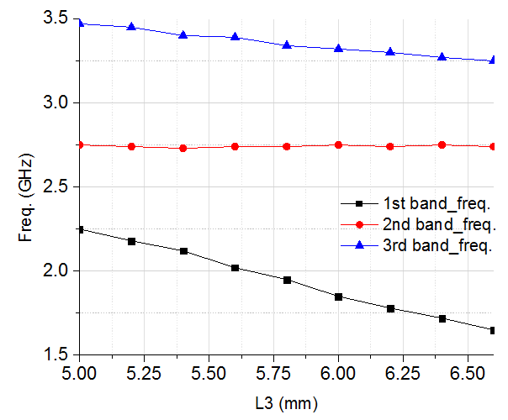
Fig. 4. Influence of L₃ on passbands
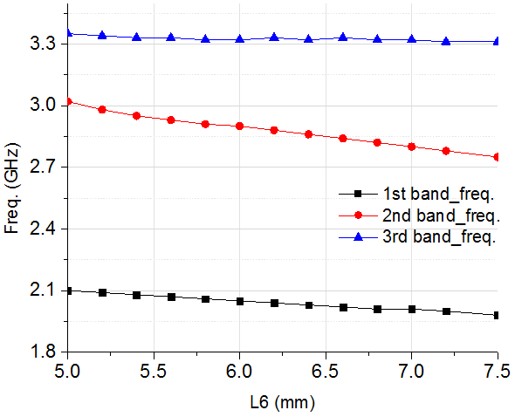
Fig. 5. Influence of L₆ on passbands
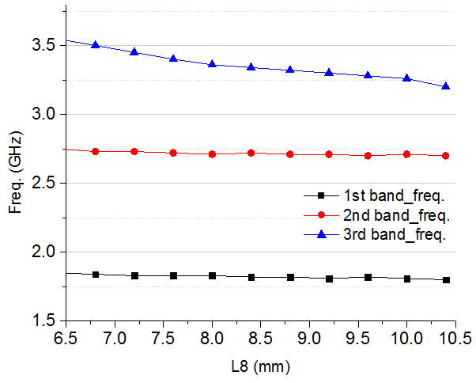
Fig. 6. Influence of L₈ on passbands
From Fig. 4, it could be observed that increasing of L₃ means the entire outer structure length $L_{a}$ is increased, then $f_{01 }$is decreased and $f_{03}$ is also felt down but slower. Whereas, the resonant frequency of the inner half wavelength, $f_{02}$, is unchanged completely.
The influence of L₆ on the passbands is shown in Fig. 5. It is remarkable that the larger $L_{6}$ is, the smaller$f_{02}$ is, while the 1st resonant frequency remains unchanged and the 3rd one changes a bit.
The resonant frequency of the 3rd passband, $f_{03}$ depends on the overall size of the cross-shaped stub loaded resonator. The frequency may be moved within an option wide range by adjusting independently the dimension of the cross-shape stub loaded tramission line. As shown in Fig. 6, only $f_{03}$ is decreased by the increased length L₈ and no effect could be observed on the others.
It could be summarized that the triple-band filter can be designed with passbands which depends on the lengths of the transmission lines of the resonators in independent way. The changing of overall length of the outer cross-shaped stub loaded resonator has no influence on the resonant frequency of the inner half wavelength resonator (Fig. 5). Although both odd and even resonant frequencies are affected together by controlling L₃, related to its overall length $L_{a}$ (Fig. 4), the problem can be controlled by fixing $f_{01 }$, related to $L_{a}$, at first then changing $L_{8}$ to obtain $f_{03 }$as shown in Fig. 6.

FILTER IMPLEMENTATION
The proposed filter is designed with center frequencies of three demanded passbands of f₀₁ = 2.0 GHz, f₀₂ = 2.7 GHz, and f₀₃ = 3.3 GHz. Using the HFSS-aided design procedure, the physical dimensions of the microstrip lines are optimized to maximize S₂₁ at the resonant frequencies. The optimized ones is shown in Table I.

TABLE I
PHYSICAL DIMENSIONS OF THE TRIPLE-BAND FILTER
Symbol | Value | Unit | Symbol | Value | Unit
w | 1.52 | mm | L₃ | 6.00 | mm
w₁ | 1.00 | mm | L₄ | 7.00 | mm
w₂ | 0.70 | mm | L₅ | 14.6 | mm
d | 3.05 | mm | L₆ | 6.55 | mm
h | 0.508 | mm | L₇ | 6.90 | mm
L₁ | 11.9 | mm | L₈ | 9.60 | mm
L₂ | 9.10 | mm

After optimization, the filter is fabricated on two-layer PCB. The PCB is Rogers RT/Duroid 5880 which has substrate with dielectric constant $ε_{r}=2.2$ and thickness of 0.508 mm. Fig. 8 introduces the photo of the filter with final geometry parameters as in Table I. The fabricated filter has been measured using the Agilent N5245A Vector Network Analyzer.
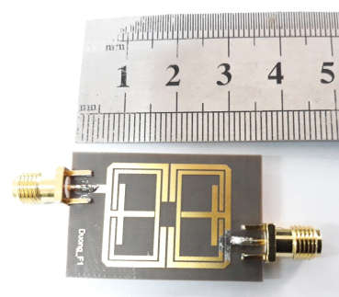
Fig. 7. A photo of the fabricated filtering prototype
The simulation and measurement results are shown together in Fig. 8. The pink and green dashed lines show simulated S₁₁ and S₂₁ parameters of the filter while the blue and brown solid lines show measured ones.
The Table II presents several measured results of the filter in details. Beside popular parameters of Insertion Loss (S₁₁) and Return Loss (S₂₁), Fractional Bandwidth is defined by:
$FBW=\frac{{BW}_{3dB}}{f_{0}}$ (9)
and the selectivity $K_{S}$ is given by:
$K_{S}=\frac{BW_{20dB}}{BW_{3dB}}$ | (10)
where $BW_{3dB} and BW_{20dB}$ are the bandwidths at S₂₁= -3dB and S₂₁= -20dB, respectively and f₀ is the center frequence of the passband. The in-band selectivity is improved as $K_{S}→1$. That means the smaller the transition region is, the better the out-of-band attenuation is.
As shown in Fig. 8 and Table II, the measured results ate nearly matched with the simulated ones. At resonant frequencies, Insertion Loss and Return Loss parameters are larger than -3.5dB and less than -20dB. They are acceptable for filter design. The FBW of 2.08 GHz, 2.72 GHz and 3.31 GHz bands are 4.8%, 4.0% and 4.5%, respectively. They are enough for requirement of the applications. Five transmission zeros of the triple-band filter are located at 1.78 GHz, 2.25 GHz, 2.66 GHz, 2.93 GHz, and 3.58 GHz. These transmission zeros improve both slopes of each passband and thus the filter selectivities K_{s} are rather high.
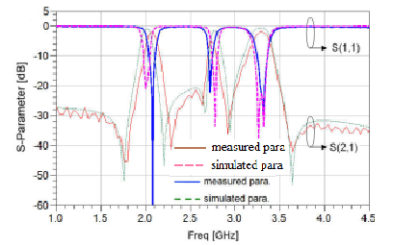
Fig. 8. Comparison results of the designed triple-band filter
TABLE II
THE MEASURED RESULTS OF THE TRIPLE-BAND FILTER
Performance Parameter | Denotation | Unit | 1st Band | 2nd Band | 3rd Band
Center Frequency | f₀ | GHz | 2.08 | 2.72 | 3.31
Insertion Loss | IL | dB | 0.78 | 3.5 | 1
Return Loss | RL | dB | 60 | 22 | 30
Fractional Bandwidth | FBW | % | 4.8 | 4.0 | 4.5
Selectivity | K_{S} | - | 2.8 | 3.0 | 2.32

CONCLUSIONS
This paper proposes a novel resonant structure for designing a high performance microstrip triple-band filter. Combining of the proposed resonator and the traditional half wavelength resonator produce a compact, low-cost, and high selectivity filter. Moreover, the center frequencies of passbands of the filter are independently tunable by changing lengths of microstrip lines in very simple way. The simulation results are experimentally verified by the prototype of triple-band filter for WiFi/RFID/Bluetooth applications and 3G/4G modern mobile communication systems.
REFERENCES
- G. Hueber; and R. B. Staszewski,Multi-Mode/Multi-Band RF Transceivers for Wireless Communications: Advanced Techniques, Architectures, and Trends, New Jersey: Wiley, 2011, pp. 1-81.
- Chao Zhu, Ruizhe Huang, Shuxi Gong, “Design of a compact triple-band antenna for Bluetooth/WLAN/WiMAX applications”, Antennas Propagation & EM Theory (ISAPE) 2012 10th International Symposium on, pp. 183-185, 2012.
- C. Yunsung, et. al, "A Dual Power-Mode Multi-Band Power Amplifier With Envelope Tracking for Handset Applications," IEEE Trans on Microwave Theory and Techniques, vol. 61, no. 4, pp. 1608-1619, April 2013.
- Bo Liu and Yimin Zhao, “Compact Tri-Band Passband Filter for WLAN and WiMAX Using Tri-Section Stepped-Impedance Resonators”, Progress In Electromagenetics Research Letters, vol. 45, pp. 39-44, 2014.
- J. S. Hong and M. J. Lancaster, “Microwave filter for RF/microwave applications.”New York. Wiley, pp 78-80, pp 18-21, 2001.
- GL. Zhu and K. Wu, “A Joint Field Circuit Model of Line-to-Ring Coupling Structures and Its Application to the Design of Microstrip Dual-Mode Filters and Ring Resonator Circuits,” IEEE Trans. Microw. Theory Tech., vol. 47, no. 10, Oct. 1999, pp. 1938-1948.
- R.J. Mao and X.H. Tang, “ Novel Dual-Mode Passband Filters UsingHexagonal Loop Resonators, ” IEEE Trans. Microw. Theory Tech., vol.54, no. 9, Sept. 2006,pp. 3526-3533.
- H. Miyake, S. Kitazawa, T. Ishizaki, I. Yamada, and Y. Nagatomi, "A miniaturized monolithic dual band filter using ceramic lamination technique for dual mode portable telephones, " 1997 IEEE MTTS Int. Microwave Symp. Dig., pp.789 792, 1997.
- L.C. Tsai and C.W. Hsue, Dual band passband filters using equal-length coupled serial shunted lines and Z transform technique, " IEEE Trans. Microw. Theory Tech., vol.52, no.4, pp.1111- 1117, April 2004.
- Kung, C. Y., Y. C. Chen, C. F. Yang, and C. Y. Huang, "Triple band parallel coupled microstrip passband filter with dual coupled length input/output,”Microwave and Optical Technology Letters, Vol. 51, 995 997, 2009.
- Chen, F. C. and Q. X. Chu, "Compact triple band passband filter using pseudo interdigital trisection stepped impedance resonators, " Microwave and Optical Technology Letters, Vol. 50, 2462 2465, 2008.
- Xuehui GUAN, Zhewang MA, Peng CAl, Yoshio KOBAYASHI, Tetsuo ANADA, and Gen HAGIWARA, "Synthesizing Microstrip Dual Band Passband Filters Using Frequency Transformation and Circuit Conversion Technique" IEICE Trans. Electron., vol. E89 C, no. 4 April 2006, pp. 459 502.
- X. Y. Zhang, J.-X. Chen, Q. Xue, and S.-M. Li, “Dual-Band Bandpass Filters Using Stub-Loaded Resonators” Microwave and Wireless Components Letters, IEEE, Vol. 17, no. 8, pp. 583–585, 2007.
- Pozar, D. M."Microwave engineering” New York: J. Wiley & Sons, 4th ed., 2011.

