Original Article
Influences of growth durations on characteristics of NaYF₄:(Yb,Tm) upconversion materials
Dung T. Nguyen¹, Thanh V. Hoang¹, Nguyen Dinh Lam¹*
¹Faculty of Engineering Physics and Nanotechnology, VNU University of Engineering and Technology, 144 Xuan Thuy Road, Cau Giay District, Hanoi, Vietnam
Received 27 October 2019
Revised 1 December 2019; Accepted 3 December 2019
Abstract: NaYF₄:(Yb,Tm) upconversion materials were synthesized by the simple hydrothermal method. Growth duration was varied from 4h to 12h under a growth temperature of 150ºC. The structural, optical and surface morphology characteristics of the NaYF₄:(Yb,Tm) UC materials were investigated. The XRD and SEM results illustrated that the NaYF₄:(Yb,Tm) materials were transformed from the multiple phases (hexagonal and cubic) to the single-phase (hexagonal prism) as growth duration being longer than 8h with the average diameter and length of these prisms being about 0.5 µm and 2 µm, respectively. Under 980 nm laser excitation, the NaYF₄:(Yb,Tm) emits at peaks of 450 nm (¹D₂→ ³F₄), 475 nm (¹G₄→³H₆), 647 nm (¹G₄→³F₄) and 697 nm (³F₃→³H₆), with the highest emission belonging to NaYF₄:(Yb,Tm) grown for 8h.
Keywords: NaYF₄:(Yb,Tm), upconversion materials, photoluminescence, growth duration, hydrothermal method.

1. Introduction
Recently, Lanthanide-doped upconversion nanocrystals (UCNCs) have captured special attention of scientists over the world because of their particular properties [1, 2]. These UCNCs materials enable to produce strong anti-stokes luminescence, efficiently converting NIR light to UV/VIS emissions, by absorbing several low energy photons and afterward emitting higher energy photons via intermediate long-lived electronic states of lanthanides [3]. The lanthanide-doped upconversion nanocrystals have been used in different areas such as solar cells [4], water treatment [4], lasers [5], sensors [6, 7], bio-imaping [8, 9] because of its chemical stability, low toxicity, large anti-stock shift sharp, and emission bandwidths [10].
The efficiency of the up-conversion process significantly depends on the rate of non-radiative transitions within the RE³⁺ ion. Among upconverting host materials such as LaF₃, PbF₂, CaF₂, SrF₂, BaF₂, sodium yttrium fluoride (NaYF₄) has been proven to be an ideal host material because of its low photon cutoff energy so that it effectively reduces non-radiative energy losses at the intermediate states of RE³⁺ ions. NaYF₄ can exist in two different crystalline phases which are cubic and hexagonal structure. Recent studies have shown that the hexagonal phase of UCNCs offers a higher magnitude of up-conversion luminescence intensity than the cubic phase does [11, 12]. Hence the hexagonal phase becomes an interesting target in preparation of NaYF₄ UCNCs. The two crystal forms can be mutually converted by heat treatment [13]. However, the hexagonal NaYF₄ (β-NaYF₄) is thermodynamically less stable than the cubic NaYF₄ (α-NaYF₄) which attribute to the mixture of crystallographic phases in synthesized samples. In order to solve this problem, lanthanide ions, having higher ionic radii than that of Y³⁺, such as europium (Eu) and terbium (Tm), can be added into NaYF₄ UCNCs to stabilize its hexagonal phase. There are some studies about the phase transformation of NaYF₄ depending on the temperature and concentration of lanthanide ions [12, 14]. Besides, the methods of synthesis β-NaYF₄ upconversion materials from a simple method (solid-state reaction) to complexity (co-thermolysis) have been well documented [13]. However, the effect of growth duration on β-NaYF₄ formation in the hydrothermal process at 150ºC is not reported.
In this study, a simple hydrothermal method has been utilized for the synthesis of NaYF₄: (Yb,Tm) and then investigated the influence of growth duration on the structure of materials and photoluminescence intensities.
2. Materials and Methods
NaYF₄:(47%Yb, 2%Tm) - mol% was prepared from YbCl₃.6H₂O, YCl₃.6H₂O, TmCl₃.6H₂O, NaOH, NH₄F, and ethanol. All chemicals are analytic grade and used as received without further purification. The synthesis of β-NaYF₄: :(47%Yb,2%Tm)- mol% UCNCs was carried out by the following steps. Firstly, 0.6g NaOH was added to a mixture of 4 ml acetic acid and 16 ml ethanol. A fixed ratio of YbCl₃.6H₂O, YCl₃.6H₂O, TmCl₃.6H₂O of 51:47:2 in mol % and 0.29 g NH₄F were then dissolved in the above solution and stirred till to generate the homogeneous growth solution. Afterward, the growth solution was put in the autoclave and undergone the hydrothermal process at 150ºC for the various growth durations of 4, 5, 6, 7, 8, and 12h. Finally, the autoclave was slowly cooled down to room temperature. The white precipitate NaYF₄:(Yb,Tm) was then washed with a mixture of DI water and ethanol by centrifuge process and dried for 12h at 80ºC.
The surface morphologies of NaYF₄:(Yb,Tm) UCNCs were characterized by field emission scanning electron microscopy (FESEM, Hitachi, S-4800) while the crystal phases were determined using an X-ray diffractometer (XRD) with Cu K_{α} radiation (λ= 1.5406 Å) over the 2θ range 10-70º at room temperature. The upconversions photoluminescence (UPL) spectra were studied by a spectrometer under excitation at 980 nm using laser diode.
3. Results and Discussions
3.1. XRD analysis
NaYF_{4:}(Yb,Tm) crystals are formed under two stages of nucleation and crystal growth. The growth duration plays a significant role in the crystal growth where the size of the crystals was defined, after shaped in the nucleation process [14-16]. To investigate the growth duration effect to the crystal phases, the different growth duration of the hydrothermal process was carried out. XRD patterns of various samples synthesized at different growth durations were illustrated in Figure 1(a). The crystal structures of NaYF_{4:}(Yb,Tm) exits in two phases (the cubic and the hexagonal phases). For the growth duration between 4h and 7h, the diffraction peaks of NaYF₄ crystals appear to be in the coexistence of β-NaYF₄:(Yb,Tm) and α-NaYF₄:(Yb,Tm). The result indicates that with the longer growth duration, the more percentage of hexagonal phase crystals are favored while the percentage of cubic phase is decreased. With growth duration being longer than 8h, the single hexagonal phase is achieved, which is illustrated in Fig.1 (b) [13].

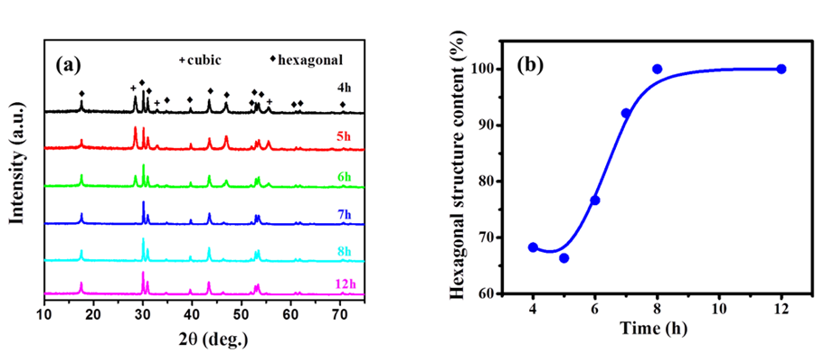
Figure 1. (a) XRD patterns for NaYF4: (Yb,Tm) samples prepared at different growth durations. (b) The percentage of the hexagonal phase in synthesized NaYF4: (Yb,Tm) samples versus various growth durations.
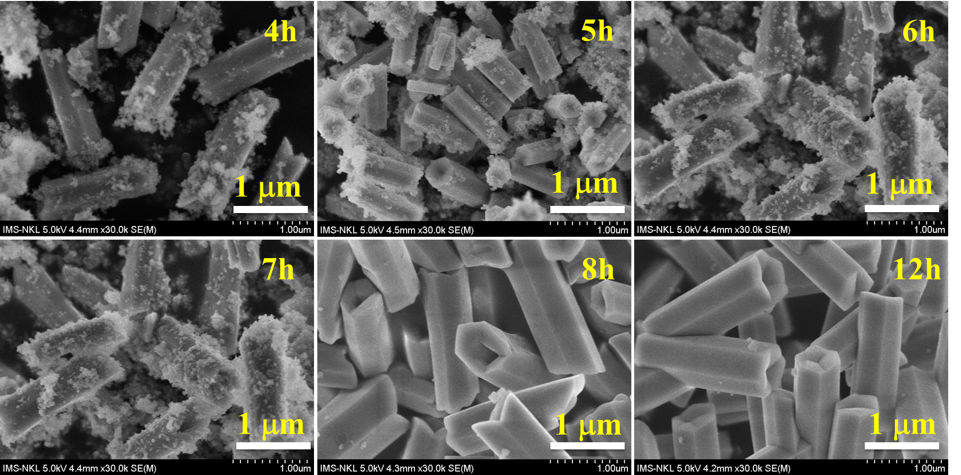
Figure 2. SEM images of NaYF_{4:}(Yb,Tm) crystals at different growth durations.

3.2. SEM analysis
Fig. 3 shows SEM images of NaYF_{4:}(Yb,Tm) crystals which were synthesized at different growth durations. It shows that the samples are in the coexistence of the prism, which is identified as hexagonal prism phase, and the nanoparticles, which is determined as the cubic phase of NaYF₄:(Yb,Tm) UCNCs. When growth duration is prolonged, the percentage of the nanoparticles in the samples decreases. After the growth durations being longer than 8h, the samples are a purely hexagonal prism. The results from SEM images are consistent with the XRD results. The average length and diameter of these β-NaYF₄:(Yb,Tm) are about 0.5 µm and 2 µm, respectively and the size of the product is well uniformed while the size of α-NaYF₄:(Yb,Tm) is about 25 nm.
3.3. Up-conversion luminescence (UCL) property
The growth duration defines the crystal phase of NaYF_{4:}(Yb,Tm). The more hexagonal phase is given at a longer growth duration. The up-conversion lumine scence process can undergo different mechanisms and the energy level structure, which can be easily found [17, 18]. Fig. 3 shows that after being excited at 980 nm, NaYF_{4:}(Yb,Tm) emits UCL at peaks of 450 nm and 475 nm (blue emission), 645 nm and 795 nm (red emission), which correspond to the ¹D₂→³F₄, ¹G₄→³H₆, ¹G₄→³F₄, and ³F₃→³H₆ transitions of Tm³⁺ ions, respectively. As can be seen in Fig. 3, UCL intensity increases with an increase in growth duration and reaches the highest value with the growth duration of 8h. Hence, the optimization of growth duration is 8h. The UCL intensity of NaYF₄: (Yb,Tm) grown for 8h is about fivefold higher than that for 5h. The intensity of UCL gradually increases when the growth duration raises. The XRD results illustrate that the relative content of the β-NaYF₄:(Yb,Tm) increases as the growth duration raise, and so does the UCL intensity. Therefore, the high efficiency of UCL emission of β-NaYF₄:(Yb,Tm) is due to the higher percentage of β -NaYF₄:(Yb,Tm) in synthesized samples. The decrease of UCL intensity of samples which are grown beyond 8h of growth duration can be ascribed to the effect of longterm heating to luminophores [19].

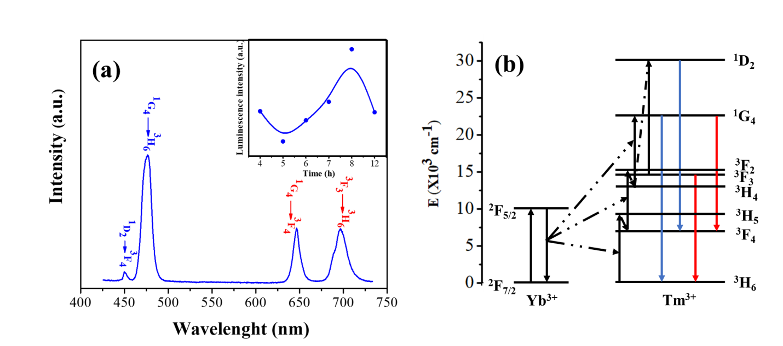
Figure 3. (a) UCL spectrum was measured for NaYF4: (Yb,Tm) UCNCs under excitation at 980 nm. In the inset: The dependence of the blue luminescence intensity (475 nm) on growth durations. (b) The energy-level diagram of up-conversion excitation and visible emission of Yb³⁺ and Tm³⁺ ions in NaYF₄:(Yb,Tm) UCNCs.

The energy-level diagram in Fig. 3(b) shows up-conversion emission mechanism of Yb³⁺/Tm³⁺ in NaYF₄:(Yb,Tm) UCNCs. Firstly, Yb³⁺ can be excited by absorbing 980 nm light and then transfer such excitation energy to Tm³⁺. The electrons of Tm³⁺ are then excited from the ³H₆ level to the ³H₅ level by receiving excitation energy transferred from Yb³⁺ and then excited to the ¹D₂ level and ¹G₄ level by absorbing the energy of other excited electrons from Yb³⁺. Finally, the transition between ¹D₂ → ³F₄ and ¹G₄→³H₆ produced to up-conversion luminous in 450 nm and 475 nm, respectively. Similarly, the peak of 647 nm and 695 nm come from energy transition of ¹G₄ and ³F₃ level, respectively. It is obvious that the co-doped materials demonstrate high up-conversion efficiency, which is due to the well uniformed hexagonal prism structure.
4. Conclusions
NaYF₄:(Yb,Tm) with the single hexagonal prism structure was synthesized by a simple hydrothermal method. It was illustrated that the structure of materials depends on the various growth durations, which transformed from the multiple phases (hexagonal and cubic phases) to the single hexagonal prism phase as growth duration being longer than 8h. These hexagonal prisms have an average length and diameter of about 2 µm and 0.5 µm, respectively. Under 980 nm laser excitation, NaYF₄:(Yb,Tm) emits at peak of 450 nm (¹D₂→ ³F₄), 475 nm ( ¹G₄→³H₆), 647 nm (¹G₄→³F₄) and 700 nm (³F₃→³H₆). The UC luminescence intensity reached the maximum value when the NaYF₄:(Yb,Tm) was grown for 8h, which contribute by the high efficiency of UCL of the purely hexagonal phase of NaYF₄:(Yb,Tm).
Acknowledgments
This work has been supported by VNU University of Engineering and Technology under project number CN19.03
References
1. L. Wang, R. Yan, Z. Huo, L. Wang, Fluorescence resonant energy transfer biosensor based on upconversion-luminescent nanoparticles, Angew. Chem. Int. Ed. Engl. 44 (2005) 6054-6057. https://doi.org/10.1002/anie.200501907.
2. S. N. Shan, X. Y. Wang, N.Q. Jia, Synthesis of NaYF₄:Yb³⁺, Er³⁺ upconversion nanoparticles in normal microemulsions, Nanoscale Res. Lett. 6 (2011) 539-539. https://doi.org/10.1021/nl070235+.
3. T. Hinamoto, H. Takashima, H. Sugimoto, M. Fujii, Controlling Surface Plasmon Resonance of Metal Nanocap for Upconversion Enhancement, J. Phys. Chem. C 121 (2017) 8077-8083. https://doi.org/10.1021/acs.jpcc.7b01010.
4. Q. Guo, J. Wu, Y. Yang, X. Liu, J. Jia, J. Dong, Z. Lan, J. Lin, M. Huang, Y. Wei, Y. Huang, High performance perovskite solar cells based on β-NaYF₄:Yb³⁺/Er³⁺/Sc³⁺@NaYF₄ core-shell upconversion nanoparticles, J. Power Sources 426 (2019) 178-187. https://doi.org/10.1016/j.jpowsour.2019.04.039.
5. M. H. Huang, S. Mao, H. Feick, H. Yan, Y. Wiu, H. Kind, E. Weber, R. Russo, P. Yang, Room-temperature ultraviolet nanowire nanolasers, Science 292 (2001) 1897-1899. https://dx.doi.org/10.1126/science.1060367.
6. R. Gao, C. Hao, L. Xu, C. Xu, H. Kuang, Spiny Nanorod and Upconversion Nanoparticle Satellite Assemblies for Ultrasensitive Detection of Messenger RNA in Living Cells, Anal. Chem. 90 (2018) 5414-5421. https://doi.org/10.1021/acs.analchem.8b00617.
7. M. Buchner, U. Ngoensawat, M. Schenck, C. Fenzi, N. Wongkaew, L. Colangelo, T. Hirsch, A. Duerkop, A. Baeumner, Embedded nanolamps in electrospun nanofibers enabling online monitoring and ratiometric measurements, J. Mater. Chem. C. 5 (2017) 9712-9720. https://doi.org/10.1039/c7tc03251j.
8. F. Wang, E. Banerjee, Y. Liu, X. Chen, X. Liu, Upconversion nanoparticles in biological labeling imaging and therapy, Analyst. 135 (2010) 1839-1854. https://doi.org/10.1039/c0an00144a.
9. H. S. Mader, P. Kele, S. M. Saleh, O. S. Wolfbeis, Upconverting luminescent nanoparticles for use in bioconjugation and bioimaging, Curr. Opin. Chem. Biol. 14 (2010) 582 596. https://doi.org/10.1016/j.cbpa.2010.08.014.
10. G. Yi, H. Lu, S. Zhao, Y. Ge, W. Yang, D. Chen, L. H. Guo, Synthesis Characterization and Biological Application of Size-Controlled Nanocrystalline NaYF₄:Yb,Er Infrared-to-Visible Up-Conversion Phosphors, Nano. Letters 4 (2004) 2191-2196. https://doi.org/10.1021/nl048680h.
11. F. Wang, J. Wang, X. Liu, Direct evidence of a surface quenching effect on size-dependent luminescence of upconversion nanoparticles, Angew. Chem. Int. Ed. Engl. 49 (2010) 7456-7460. https://doi.org/10.1002/anie.201003959.
12. M. Lin, M. Liu, M. Qui, Y. Dong, Z. Duan, Y. H. Li, B. P. Murphy, T. J. Lu, F. Xu, Synthesis of upconversion NaYF₄:Yb³⁺,Er³⁺ particles with enhanced luminescent intensity through control of morphology and phase, J. Mater. Chem C 2 (2014) 3671-3676. https://doi.org/10.1039/c4tc00129j.
13. K.W. Krämer, D. Biner, G. Frei, H. u. Gudel, M. P. Hehlen, S. R. Luthi, Hexagonal Sodium Yttrium Fluoride Based Green and Blue Emitting Upconversion Phosphors, Chem. Mater. 16 (2004) 1244-1251. https://doi.org/10.1021/cm031124o.
14. G. Chen, T. Y. Ohulchanskyy, R. Kumar, H. Agren, P. N. Prasad, Ultrasmall monodisperse NaYF(4):Yb(3+)/Tm(3+) nanocrystals with enhanced near-infrared to near-infrared upconversion photoluminescence, A.C.S. nano 4 (2010) 3163-3168. https://doi.org/10.1021/nn100457j.
15. S. Dühnen, T. Rinkel, M. Haase, Size, Control of Nearly Monodisperse β-NaGdF₄ Particles Prepared from Small α-NaGdF₄ Nanocrystals, Chem. Mater. 27 (2015) 4033-4039. https://doi.org/10.1021/acs.chemmater.5b01013.
16. T. Rinkel, J. Nordmann, A. N. Raj, M. Haase, Ostwald-ripening and particle size focussing of sub-10 nm NaYF(4) upconversion nanocrystals, Nanoscale 6 (2014) 14523-14530. https://doi.org/10.1039/C4NR03833A.
17. W. Huang, M. Dinh, H. Huang, C. Jiang, Y. Song, Y. Ni, C. Lu, Z. Xu, Uniform NaYF₄:Yb, Tm hexagonal submicroplates: Controlled synthesis and enhanced UV and blue upconversion luminescence, Mater. Res. Bull. 48 (2013) 300-304. https://doi.org/10.1016/j.materresbull.2012.10.031.
18. L. Wang, Y. Li, Na(Y1.5Na0.5)F₆ Single-Crystal Nanorods as Multicolor Luminescent Materials. Nano Letters 6 (2006) 1645-1649. https://doi.org/10.1021/nl060684u.
19. J. Du, O. Q. D. Clercq, D. Poelman, Temperature depent persistent luminescence: Evaluating te optimum working temperature, Scientific Reports 9(2019) 10517. https://doi.org/10.1038/s41598-019-46889-z.

